
Autumn Stay and Play Session

Dear Parents and Carers,

We are excited to invite you to our ‘Stay and play’ session for Reception and Nursery on Monday 7th December at 9 am.
We will have lots of fun themed activities for you to engage in with your child. It will be an opportunity for you to see how well your child has settled and a chance to explore the classroom environment together. We are looking forward to spending the morning with you all!

Kind regards,

Early Years Team

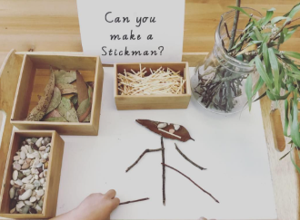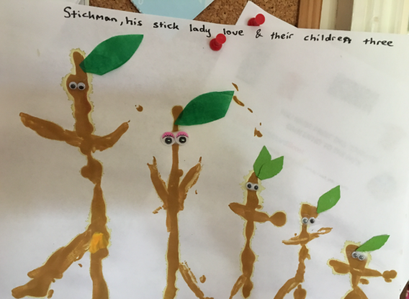





Our School Values are: Perseverance, Courage, Forgiveness, Friendship, Honesty and Acceptance








