

Dear Parents/ Carers,

Your child will be taking part in a curriculum enhancement day on Wednesday 9th September 2026 in order to introduce them to our new topic; ‘Movers and Shakers’. During this exciting day, your child will be attending ‘Art school’ and will be exploring a range of artists and techniques.

We kindly ask that your child comes dressed to school as an artist on this day.

We have lots of very exciting activities planned and cannot wait to complete these with your child. We are sure that this will provide a fantastic start to the next term and the project.

Thank you,
Mrs Cook, Miss Cawthray, Miss Nicklin



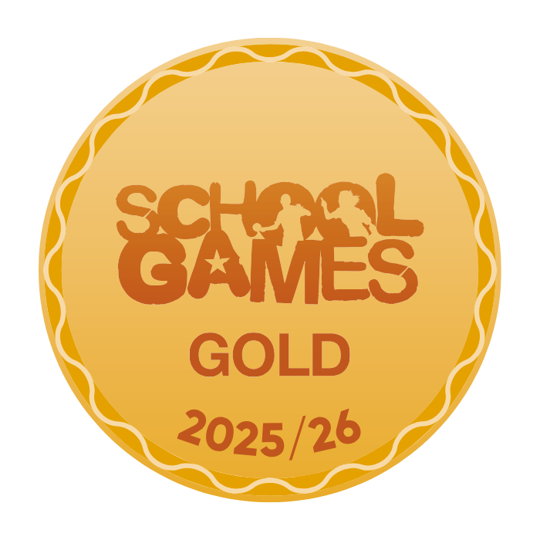





Our School Values are: Perseverance, Courage, Forgiveness, Friendship, Honesty and Acceptance





