Thursday, 25th September, 2020


Dear Parents/Carers

I am writing to inform you of our plans for remote learning should your child have to be absent from school for any reason associated with the COVID-19 pandemic.
We have adopted a tiered approach to our home learning offer, as we recognise that some children may only be required to remain absent from school for a short while whilst awaiting a test result whilst others may be absent for longer periods of time.
I hope you can appreciate, that when formulating our plan, we have also had to take into account that if individual children are required to isolate, our staff will still be required to teach the rest of their ‘bubble’ full time and therefore, we cannot offer home learning to the same extent as if the bubble was closed or in the event of a lockdown.
I have attached our home learning contingency plan for your perusal as well as a flow chart so that you can see what work you can expect your child to be set and how you should submit it to the class teacher.
There is an expectation that if your child is absent but well and able to participate in home learning, that they will do so and our staff have been instructed to monitor engagement with this; therefore, we would really appreciate your support in ensuring that your child completes the work set.
We have tried to ensure that video lessons (either from Oak Academy or our own teachers) are used for the majority of the time so that the help your child will need from you in order to access the lessons is minimal.
All the resources you need for your child’s lessons will be placed on our website on the year group/class pages.
For Plan 1 and 2, (please see contingency plan below) links to video lessons on the Oak National Academy will be used. These lessons will closely match what other children in the year group are learning within school in order to prevent your child from feeling ‘behind’ when they return. Each Oak Academy lesson has a quiz at the end. A screenshot or photo of the quiz result should be sent to the class teacher by email so that they can monitor how well your child has done during the lessons and evaluate whether your child would benefit from further support. All teacher emails are on the class pages and details of the minimum amount of contact your child should receive from their class teacher is detailed on the contingency plan attached. Please be sure to answer any calls that show as a ‘withheld’ number as it could be one of our staff who is working from home!
Plan 3 is the more extensive package that we are offering in the event of a bubble closure or lockdown. This will be approached in a different way to Plan 1 and 2 as we will have the capacity to cater more specifically for the children that attend our school because our staff will not be teaching their bubble full time as well as providing home learning.
In the event of a bubble closure or lockdown, your child will be provided with lessons recorded by one of our staff for the majority of subjects (see contingency plan for details of specific subjects). They will also be set a KAHOOT! quiz to complete so that the teacher can gain a detailed picture of how your child is performing with the tasks set for these video lessons. (More details of how to access these quizzes are given below. I will also place a video on our class page section of the website to explain how to access these).
We decided that it would be best to record lessons rather than conduct live ones as we understand that many of our families have only one device with internet access and if you have more than one child, it may be tricky for you to get your children ‘logged on’ for their lessons at the correct times.

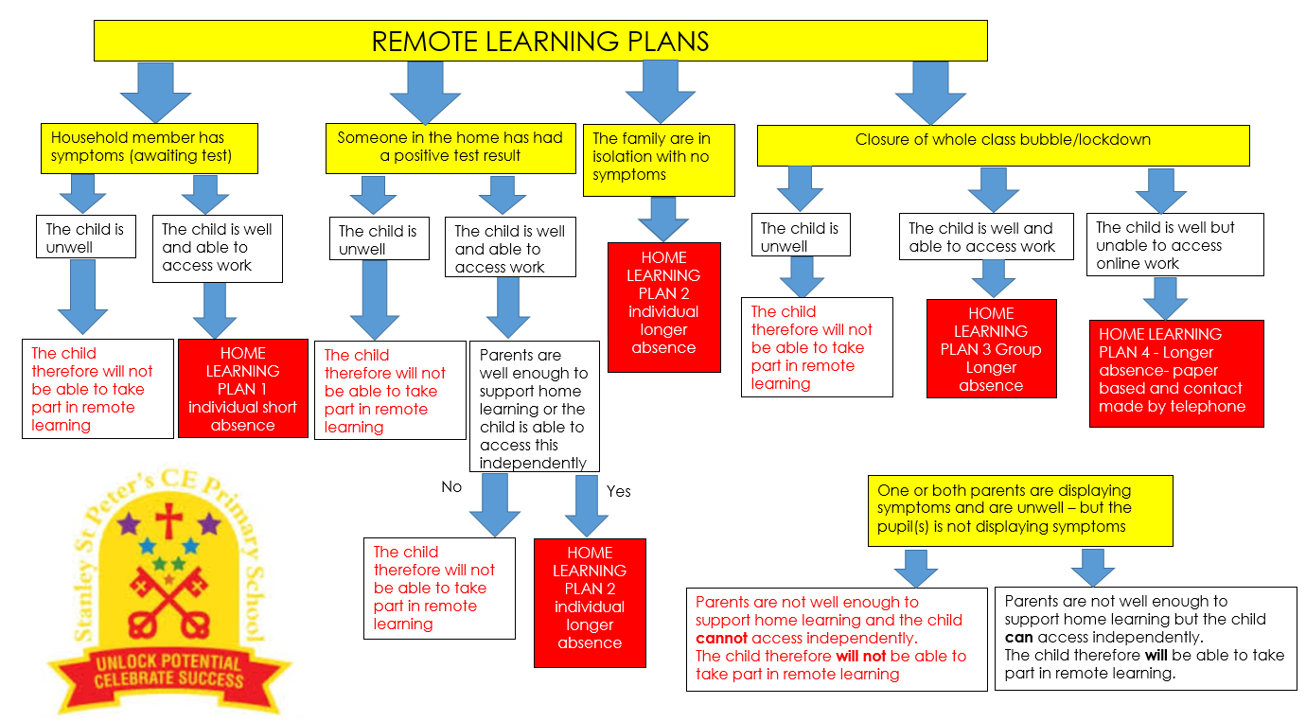
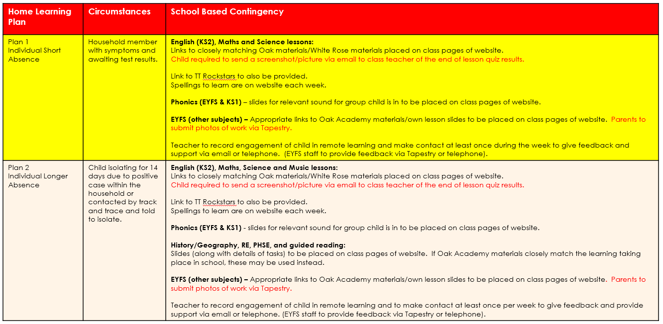
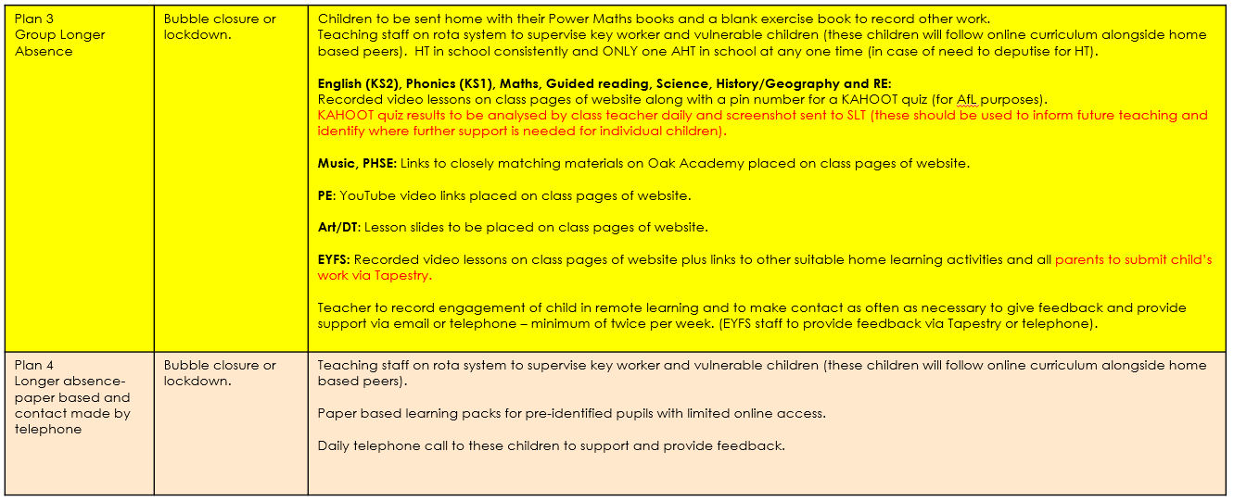
If you are finding the above documents difficult to view, they are on our website at the top of the main screen of the Class Pages titled ‘Remote learning plans” which can be accessed by clicking this link https://stanley-st-peters-church-of-england-vc-primary-school.secure-primarysite.net/class-pages/

USING KAHOOT! – Only applies to Plan 3 of our remote learning contingency plan (bubble closure or lockdown)
Our staff will put a PIN number under any lesson content that your child needs to complete a KAHOOT! quiz for.
Mobile phones and tablets:
Please download the KAHOOT! app. It will look like the logo shown below:
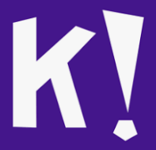
When they click on the app to open it, they will see a screen similar to this:

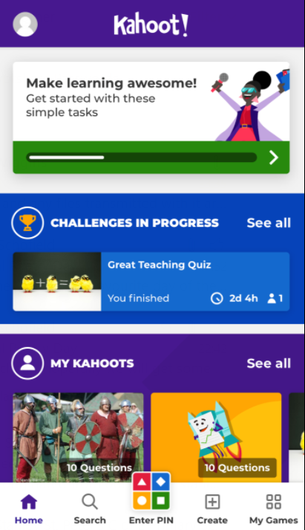
Click “Enter Pin”
You can see that in the middle at the bottom of the screen, there is a multi-coloured button which says “Enter PIN”.
Your child should click on this button and then enter the PIN provided on the year group/class page for the lesson they have just completed.
Then click “Start Playing”
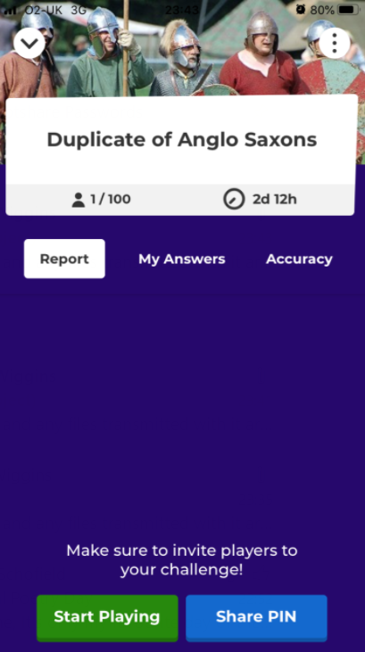
Click “Start Playing”

They will then see a screen like below with a white box at the bottom. In the white box, they should enter their full name, press submit and then press OK, go!
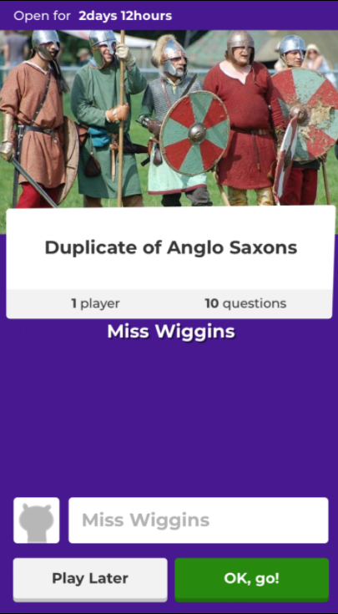
Your child will then see the first question and some possible answers. They should work their way through the quiz, tapping the answers they think are correct.
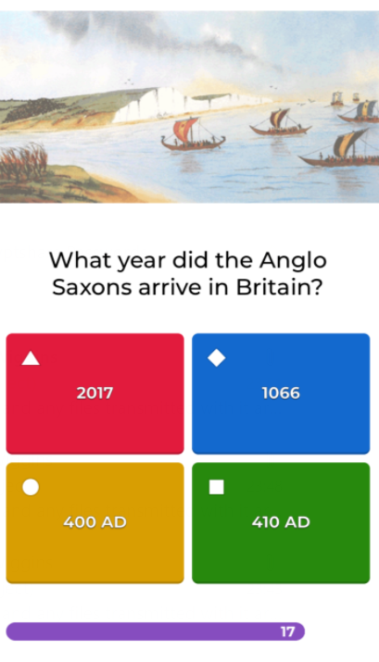
It is extremely important that your child does NOT guess the answers, but thinks carefully about them as the teachers will use the information generated from them to assess if your child requires further support. Please note, your child will have a set amount of time available to answer questions so please warn them about this. Also, remind your child that they may need to do some working out on paper to obtain the correct answer – this is fine and should be encouraged when necessary (particularly for maths questions).
Once they have completed the quiz, they will see a screen like this that will tell them how many questions they got right and they will have the chance to have another go at the ones they got incorrect.
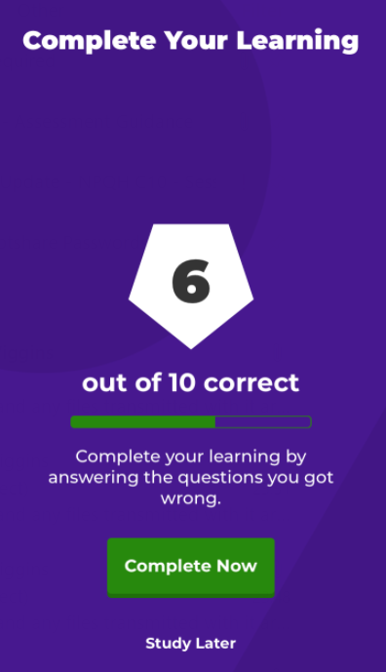
There is NO NEED to send a screenshot or photo of any KAHOOT! quizzes that your child completes (we are only asking you to do that for the quizzes taken on the Oak National Academy lessons). The teacher will be able to see your child’s result and take appropriate action/provide feedback from any KAHOOT! quizzes that they complete.
If your child is accessing the KAHOOT! quizzes on a laptop or computer, they will need to type ‘Kahoot’ in the search engine.

It should then bring up a screen like this:
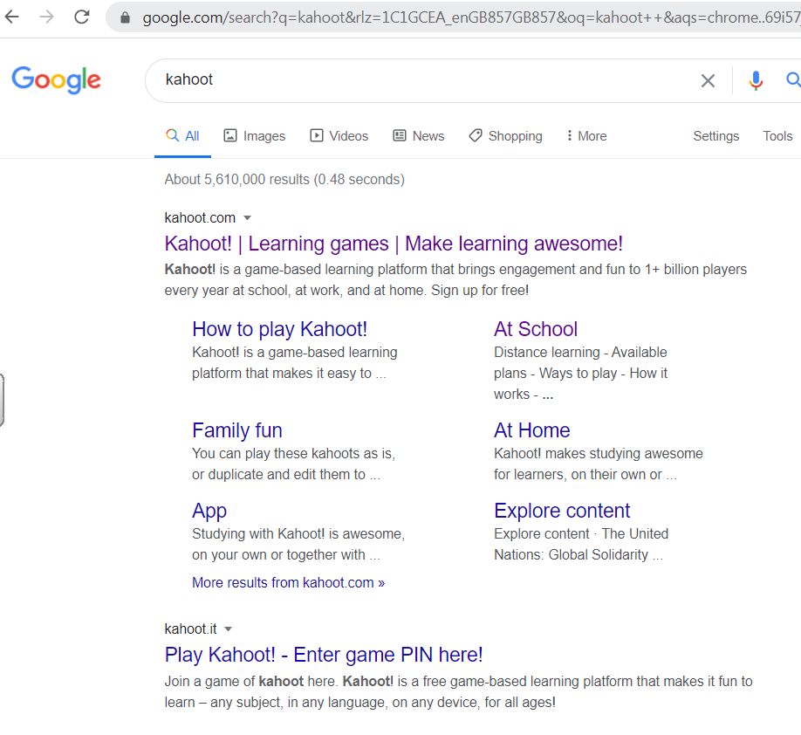
Your child should click on the second option that says “Play Kahoot! – Enter game PIN here!”
They can then enter the PIN and follow the instructions previously described.
If they see a screen like this:
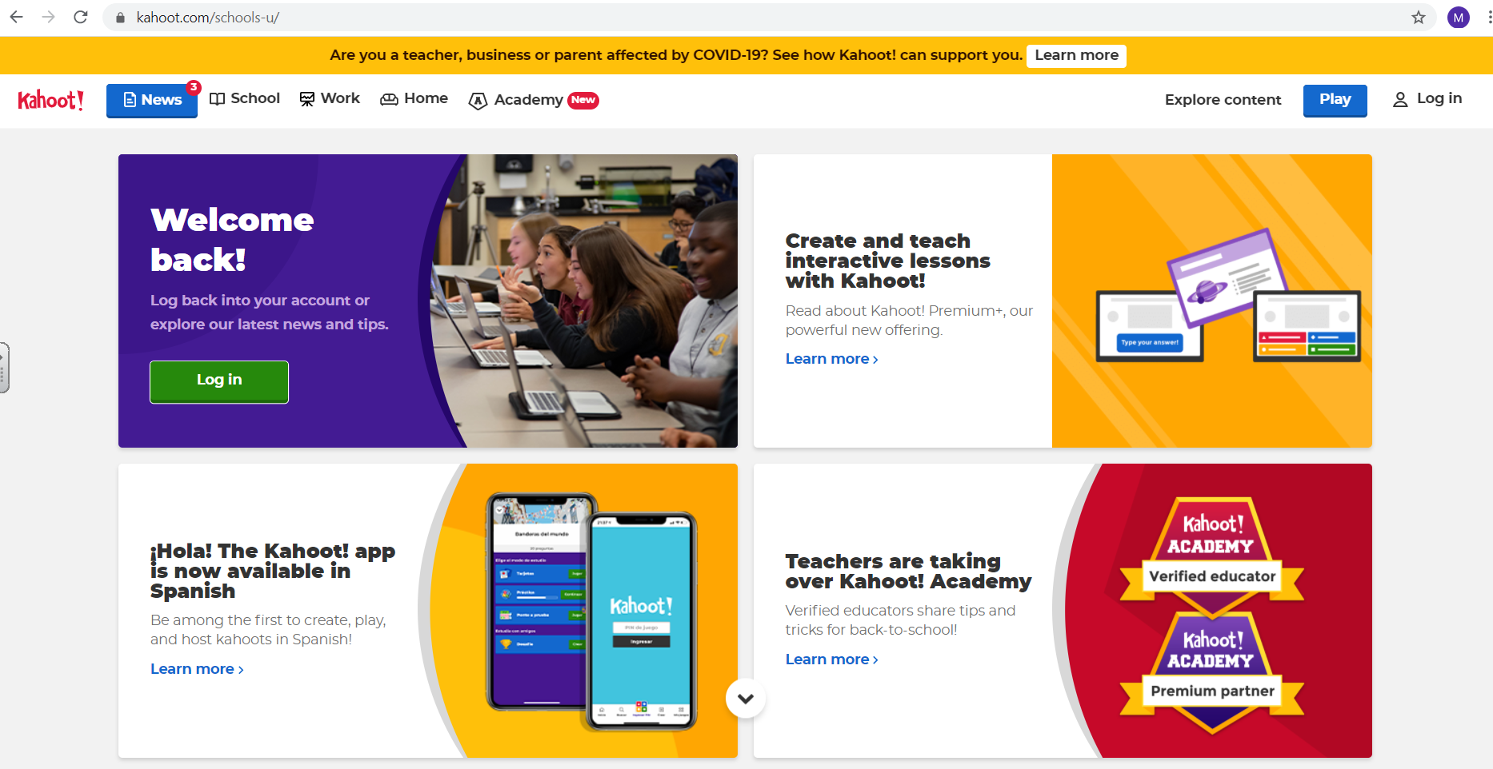
They need to click the ‘Play’ button in the top right hand corner and then continue as previously described.
I hope this information is helpful. If you have any questions or you are having difficulty with the home learning at all, please contact your child’s class teacher via email who will be only too happy to help!
Kind regards,

Michelle Wiggins
Headteacher

