
Dear parents, carers & guardians,

The online world can be a bit overwhelming at times but it is important we understand what our children are doing online so we can help make them safer. The Safer Schools App aims to help with this.

We are delighted to invite you to download our new Safer Schools App provided
by our school insurance provider Zurich Municipal.

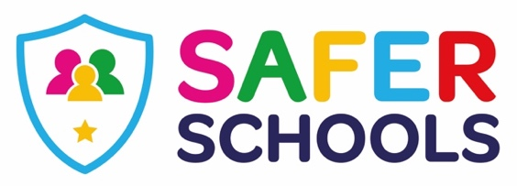

About the App
The App is designed to support and protect children by educating and empowering them both at school and at home. Through their log-in, your children get access to information that is relevant to them and you will receive tips and advice on how to keep them safer online.
Excited? Ready to make
your children safer?
Download the Safer
Schools App now!

Make sure to enable push
notifications to keep up-to-date
with our tips, advice and guidance
on how to make your children safer.

See the page below for details of how to download and use the app.
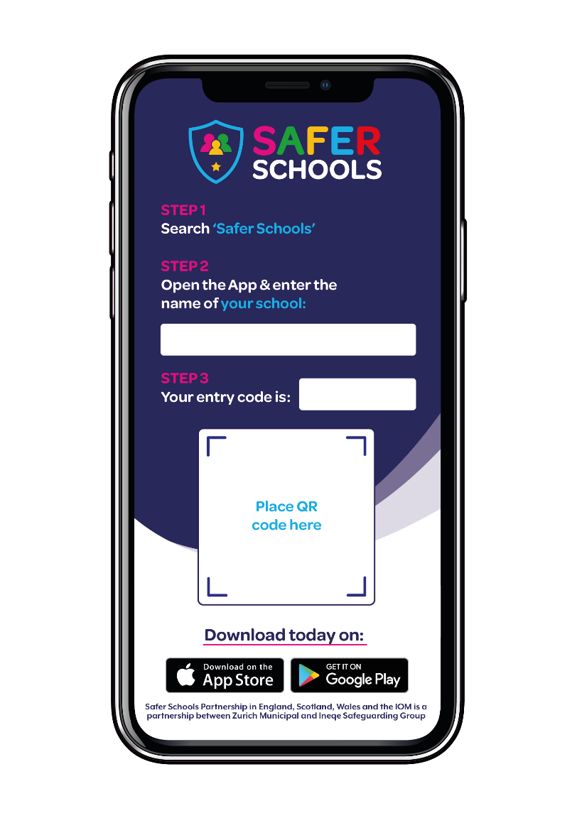

Stanley St Peters CE Primary School
7440
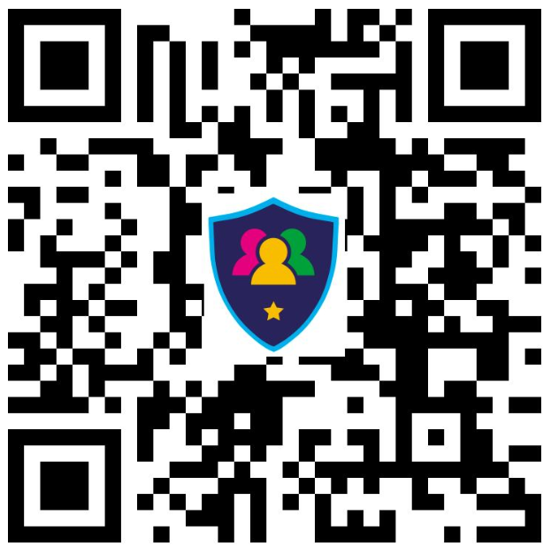
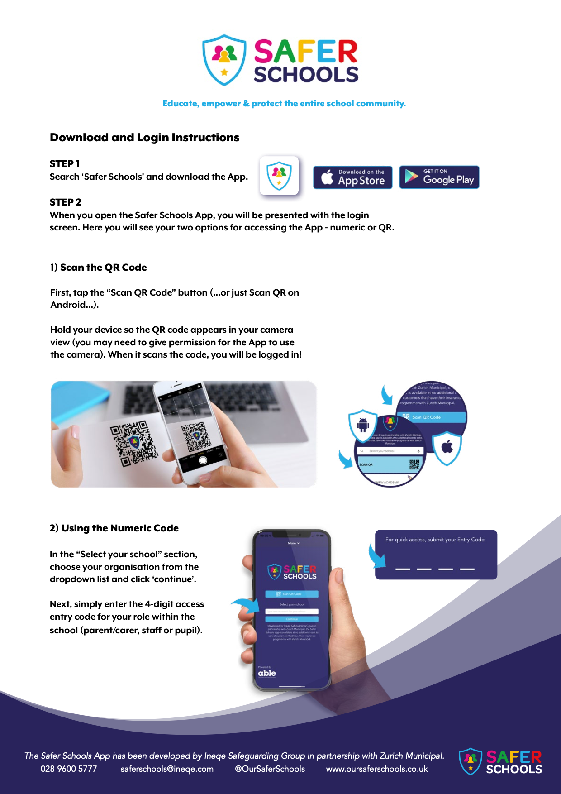
To watch a video which explains all about the app and how to download and use it, click this link… https://stanley-st-peters-church-of-england-vc-primary-school.secure-primarysite.net/internet-safety-1/

