

Monday, 19th April, 2021

COVID-19 self-test kit collection trial

Dear Parents If you would like to order more COVID self-test kits (perhaps your supply is running low), please click on the link below to order some. I will make a new online order form each week for you to be able to place your order for more tests as and when you need them.

https://forms.office.com/Pages/ResponsePage.aspx?id=_OmoEZZNfk6JWUagtnhmzy1 2Jga1nz5Jl0mh_GdlYTpUN0YxRVAzVUNHNlozVUhXU0tKMDNYNlNSQS4u

Kind regards,

Michelle Wiggins
Headteacher

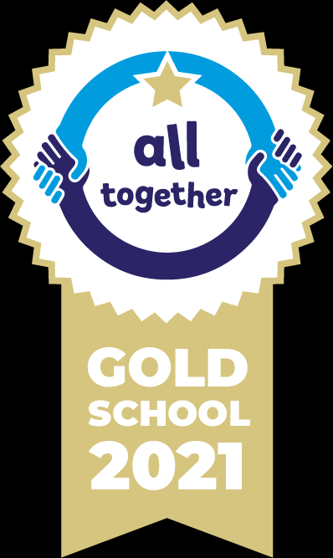





Our School Values are: Perseverance, Courage, Forgiveness, Friendship, Honesty and Acceptance

