4th May 2021

Dear Parent/Carer,

Year 3/4 trip: Royal Armouries Museum

We are delighted to inform you that Year 3 and 4 are planning an educational visit to the Royal Armouries in Leeds on Tuesday 8th June 2021. This will be part of our class project in which we will be learning about Boudicca, the Celtic Queen who rose up against the Romans. We will also get to take part in a Roman battle!

The cost per child for this educational visit is £5.20 which will include the coach travel to and from the Royal Armouries. There is no obligation to contribute, however I must emphasise that if the level of support is not sufficient to make the visit viable then unfortunately the visit will not take place for any of the children.

Payment for the trip will need to be paid online through School Money by Friday 21st May. A text will be sent to you shortly with a link and password to enable you to do this.

Children will need to bring a packed lunch with a drink of water that is completely disposable i.e no metal spoons, flasks etc in a named plastic carrier bag. If your child is on free school meals, a packed lunch will be provided.

The trip will be within school hours, drop off and pick up will be at the normal time.

We thank you for your continued support and are looking forward to sharing this experience with the children.

Yours sincerely,

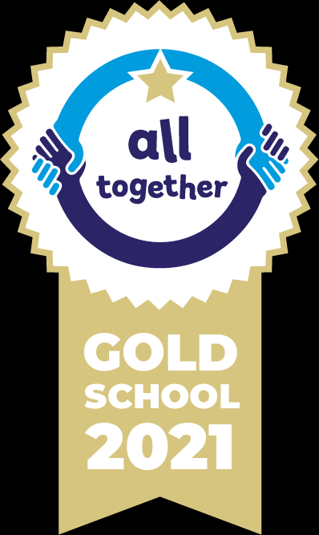
Miss Smith – Anning class
Mrs Cook – Columbus class
Miss Ogden – Shakespeare class






Our School Values are: Perseverance, Courage, Forgiveness, Friendship, Honesty and Acceptance

