

Monday, 14th June, 2021

Dear Parent/Carer

This term, as part of our RHSE curriculum, we will be covering the unit Boys, Girls and Families. In Year 2, we teach the children about the physical differences between boys and girls (they learn the scientific terms for ‘privates’ namely that boys have a penis and girls have a vagina) and that boys and girls can like and be good at the same things (football, playing with dolls etc.) They will also learn about the concept of the female breasts primary function being to feed their young (they learn this in the context of a cat feeding her kittens).
These lessons will be compulsory to all the children, but if you would like any further information, please contact your child’s class teacher.
Yours sincerely,
Miss Brown and Miss Thackrah

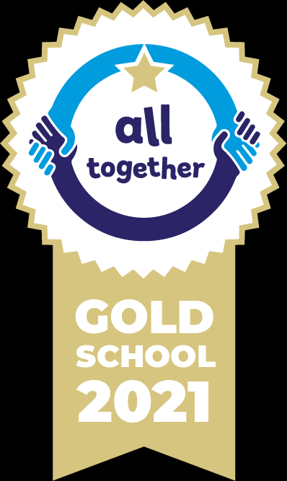





Our School Values are: Perseverance, Courage, Forgiveness, Friendship, Honesty and Acceptance

