
Monday, 28th February, 2022

Dear Parents/Carers

You will be aware that the Government’s ‘Living With COVID’ strategy was announced on 21st February, bringing with it some changes to national guidance.

The government have lifted the legal requirement to self-isolate which brings COVID into line with other infectious diseases (e.g. diarrhoea & vomiting, chicken pox, mumps, scarlet fever).

Please see below for the key points of the advice published by the United Kingdom Health Security Agency (UKHSA relevant to schools.

The key points from the advice are as follows:

- People with COVID symptoms are still advised to stay at home and get a PCR test.
- Children who test positive should stay at home and not attend school for 10 days. If they have two negative lateral flow tests 24 hours apart from day 5 onwards, then they can safely return to school on day 6.
- Children who are household contacts of a positive case can continue to attend school.
- Daily lateral flow testing is no longer specifically advised for contacts of cases.

As we have seen many times over the last two years, while we are ‘learning to live with COVID’ we can still be challenged by outbreaks in settings, sudden surges in infection, or by the emergence of a new variant. For this reason, we still have our Outbreak Management Plan published on our website and available to us to implement should we be advised to initiate this by our local public health team – although I sincerely hope we will not need it!

Kind regards,

Michelle Wiggins

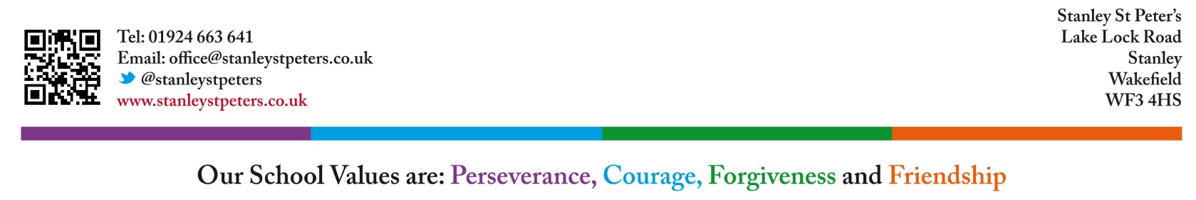


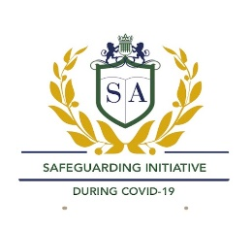
Headteacher
Our School Values are: Perseverance, Courage, Forgiveness, Friendship, Honesty and Acceptance

