
21st March 2023

Dear Parents/Carers

As part of our Easter celebrations, we would like to invite your child to create an Easter bonnet to bring to school on Friday 31st March.

Please help your child to make an Easter bonnet at home and bring it to school on Thursday 30thMarch There is no need to buy an expensive bonnet – please see the examples below made from recycled materials.

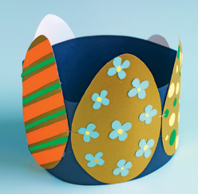
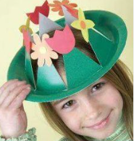


We look forward to seeing your creations.
Yours sincerely,





Early Years Team
Our School Values are: Perseverance, Courage, Forgiveness, Friendship, Honesty and Acceptance





