
31st March 2023

Dear Parent/Carers,

We are extremely excited to let you know that on Wednesday 19th April, Years 5 and 6 will be taking part in a ‘Project Immersion Day’. Following on from the success of our last immersive experience linked to our recent project, ‘Frozen Kingdoms’, we intend to engage the chidren in our next intrigueing series of history and geography lessons based on our next focus: ‘Britain at War’.

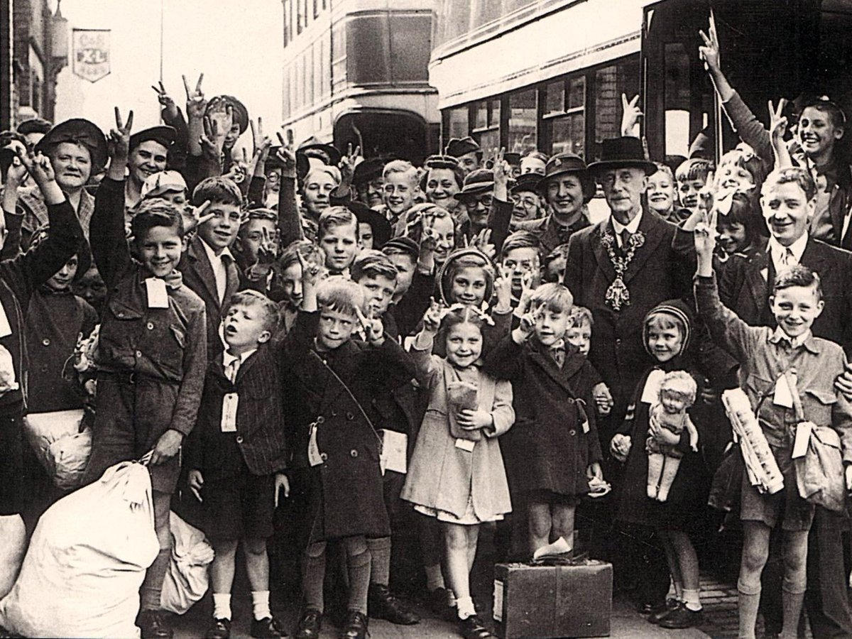
The children will take on the role of child evacuees and experience a snapshot of what life was like for this unfortunate generation. Throughout the day, the children will work collaboratively to overcome a range of challenging acvtitities as we dive deeper into this significat historical event.

To help the children take on the role of a child evacuee, we would like them to come dressed appropriately: see image beside for inspiration!

We look forward to welcoming the children back after the Easter holidays…

Mr Cundall, Miss Schofield, Mrs Backhouse and Miss Smith




Our School Values are: Perseverance, Courage, Forgiveness, Friendship, Honesty and Acceptance





