
Wednesday 16th July 2023

Dear Parents and Carers

As September fast approaches, we wanted to make sure we are fully prepared for the new year and can give you as much notice as possible.

We are pleased to inform you that we will be holding a ‘Curriculum Immersion Day’ on Wednesday 13th September 2023. This will be a full day dedicated to our new project ‘Childhood’.

Your child is going to be a ‘child from the 1950s’ for the day. Without going into too much detail (we don’t want to spoil the surprise), the children will be taught, trained and prepared for what it is like to be a child in the 1950’s. Therefore, we ask for your child to come to school on that day dressed in clothing that is taken from 1950s fashion.
Please see below, some photos of children’s fashion taken from the 1950s, for ideas.

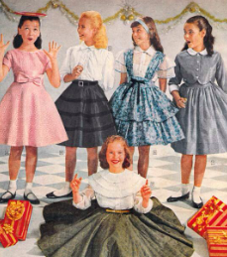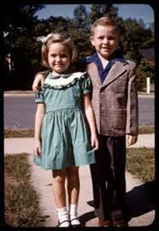
We will leave you to interpret this information in any way you like. We can not wait to see what you and the children come up with!

Kind regards,

Miss Cawthray and Miss Hutton.





Year 1
Our School Values are: Perseverance, Courage, Forgiveness, Friendship, Honesty and Acceptance








