
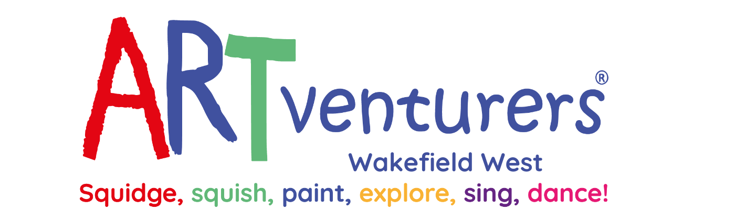

Wednesday 20th December 2023
Dear Parents and Carers,
We are very excited to inform you that ARTventurers will be running a club within Stanley St Peters!
The club would run for 4 weeks, 3.30pm until 4.30pm. The first session will start Wednesday 17th January and the last session will be Wednesday 7th February 2024.
The cost per child is £24 for the 4 weeks, which includes all materials and keepsakes that they make during the sessions.
The club will be open to children in Year 1 to Year 3 with limited places.
If your child would like a place on the ARTventurers club, please return the slip below as soon as possible. This will be on a first come first serve basis. You will be contacted if your child has a place and payment will be required once their place has been confirmed. This will be non-refundable, so please ensure your child is fully committed to attending the club. Payment will be made via School Money.
-------------------------------------------------------------------------------------------------------------------

Child’s Name …………………………………………………………. Class………………………

I would like to book a place for my child on the ARTventurers after school club. I understand that there is a non-refundable cost of £24.





Parent Signature……………………………………………………….Date…………………………
Our School Values are: Perseverance, Courage, Forgiveness, Friendship, Honesty and Acceptance









