

13th May 2024

Dear Parent/Carer,

Re: Victorian workshop – Tuesday 25th June 2024

We are delighted to inform you that Year 1 are planning a Victorian workshop on Tuesday 25th June 2024. This will be as part of our Project unit ‘School Days’ learning about school experiences from the Victorian times.

The cost of the educational workshop is £6.70 per child.
The workshop includes a Victorian classroom experience, Toys and Games carousel, Children at Work carousel and Create and Keep (where the children get to make their own toy, to keep and take home!).
There is no obligation to contribute; however, we must emphasise that if the level of support is not sufficient to make the workshop viable then, unfortunately, the workshop will not take place for any of the children.

Payment for the workshop will need to be paid online through School Money by Monday 17th June 2024. A text will be sent to you shortly with a link and password to enable you to do this.

Thank you for your continued support; we are looking forward to sharing this experience with the children.

Yours sincerely,

Miss Cawthray & Miss Hutton.

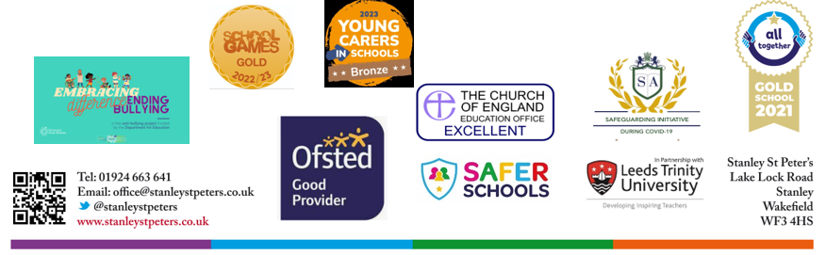

Our School Values are: Perseverance, Courage, Forgiveness, Friendship, Honesty and Acceptance

