25th October 2024

Dear Parents and Carers,

Anti Bullying Week
To launch Anti-Bullying Week, we will be having an odd socks day on Tuesday 12th November. Children can come to school wearing odd socks to celebrate what makes us unique. We are not fundraising on this day. Children will be taking part in activities in their PSHE lessons to help spread kindness, in line with the theme for this year of ‘Choose Respect’.
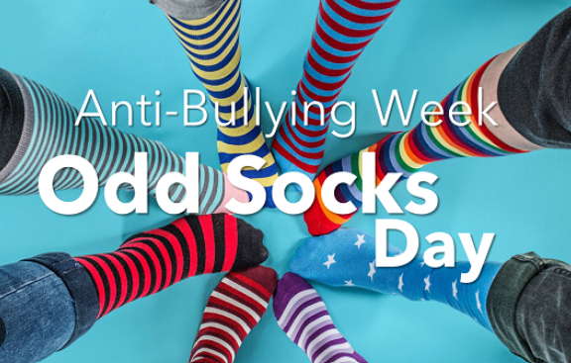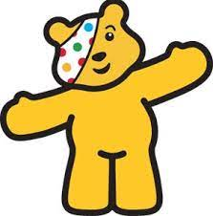
Children In Need
On Friday 15th November we will be having a non-uniform day to raise money for Children in Need. Your child can come to school in their normal clothes, PJ’s or Pudsey Bear merchandise.
If you would like your child to take part in the non-uniform event and raise some money for Children in Need, please make a donation to the JustGiving page following the link below. We are going cashless again this year!
https://www.justgiving.com/page/stanley-st-peters-1729839158573
Kind Regards,

Mrs Phillips








Our School Values are: Perseverance, Courage, Forgiveness, Friendship, Honesty and Acceptance

