
Wednesday 6th November 2024

Dear Parents/Carers,

We are excited to announce that on Wednesday, January 8th, 2025, your child will be taking part in an immersion day adventure to launch our new project: “Contrasting Environments – Our Wonderful World!”

To kickstart this term’s project, we’ll be taking a “cruise” around the world, where the children will get to explore different environments and experience the amazing diversity our planet has to offer. From tropical islands to frozen arctic landscapes, they’ll be going sightseeing, tasting delicious foods from around the globe and learning about some of the world’s most iconic sights!

On this day, we encourage all young explorers to come dressed in their best holiday attire. Hawaiian shirts, sunglasses, sun hats or cosy coats and scarves for our chilly Arctic stop – all are welcome! If they have a suitcase or backpack, they’re more than welcome to bring those along to fully immerse themselves in the adventure.

Since we’ll be travelling through various “environments”, both inside and outside, please ensure your child is dressed in layers and has suitable outdoor clothing and footwear. If the weather takes us by surprise, we’ll be ready!

We can’t wait to set sail with your child on this unforgettable day of learning, discovery and fun. We’re sure it’ll be an incredible start to the term and set the stage for a fantastic project!

All aboard for adventure!

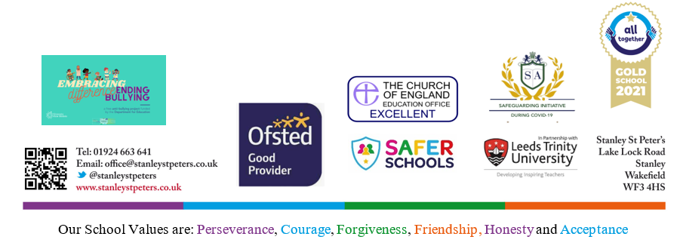
Yours sincerely,

Miss Flood, Mrs McDonald, Mrs Phillips and Miss Schofield
EYFS Team

