
28th January 2025

Year 5 – Bikeability Cycle training
Dear Parent/Guardian

Your child has the opportunity to participate in Bikeability Cycle Training. This course seeks to give children the skills and confidence to cycle safely on the road. This fun course starts in the playground and will continue on quiet roads around the school.

In order for your child to take part, you will need to complete the attached consent form and return it to school. The training is free.

Children need to be able to ride a bike to take part in Bikeability Level 1 and 2. If your child cannot ride a bike, please tick the box at the end of the consent form and we may be able to arrange a slot to teach them during our time in school.

Ideally your child will use their own bike for the training, but bikes can be loaned to those without. Please tick the box at the end of the form to request a bike and/or helmet loan.

The cycling will continue whatever the weather, so please send your child with warm and waterproof clothing. Gloves are a good idea. We suggest that pupils wear trousers or tracksuit bottoms when training.
The training will take place during school time on
Monday 24th – Wednesday 26th February 2025.
A text will be sent out confirming which day your child will be taking part in the course.

This course is being run by Cycle North on behalf of Wakefield MDC and the instructors are fully qualified, checked and insured.

Your child will need to have with them, for all their course sessions:

- A bike which is roadworthy and fits properly.
A bike check will be carried out on the first day and any bike which is not roadworthy cannot be used on the course. I’ve attached a bike check form to help you ensure that your child’s bike is in a good condition.
- A cycle helmet (which fits!)
- Warm clothing and a waterproof jacket
- Gloves if appropriate.

Your child will be continuously assessed throughout the course. The training will start with a playground session and the children must reach the required standard in cycle control, in order to proceed to the on-road Level 2 sessions that follow. At the end of the course, all children will receive a certificate that confirms their participation on the course along with a badge.

Is the bike alright to use?

The cycle training can be done on any sort of bike, as long as it is roadworthy and has both a front and back brake. Please check your bike using the checklist below. If in doubt take it to a bike shop and ask them to check it. Our trainers are not mechanics but may be able to make minor adjustments on the day. Unfortunately, if your child arrives with a bike that we do not consider safe to use on the roads, your child will not be able to do the training unless you have booked a loan bicycle with us.
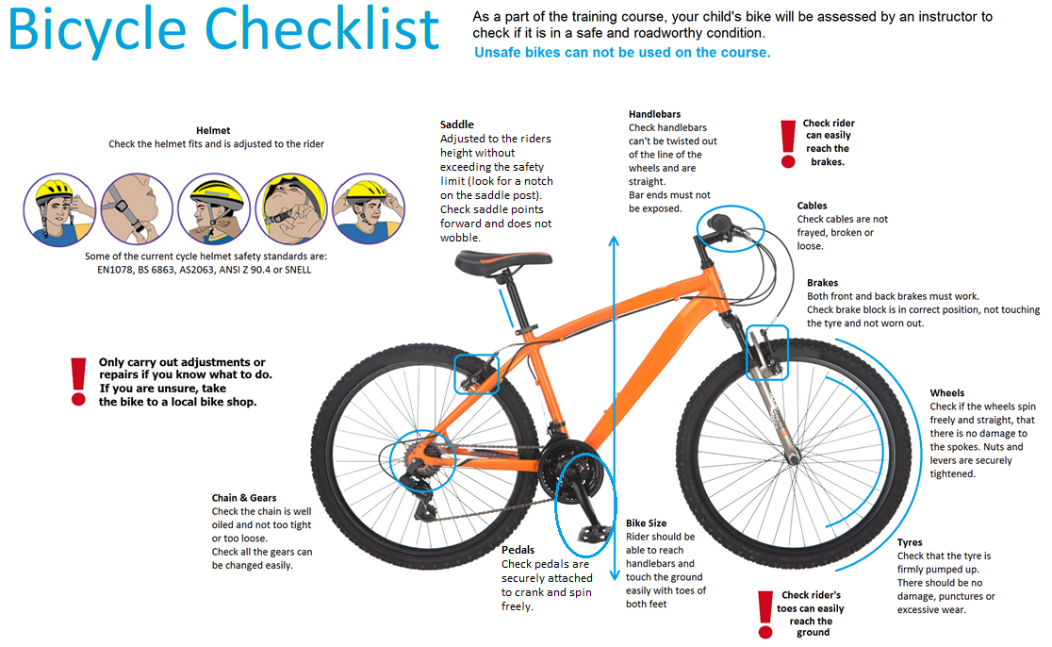

Bikeability Cycle Training Parent or Guardian Consent Form

It is now easier to sign your child up to Bikeability training. Please visit

https://consent.bikeability.org.uk/tod-count-gas

or access the site through the QR code below, and follow the online instructions.
Yours sincerely
Miss S Cawthray
PE Lead.


