
STANLEY ST PETER’S CE PRIMARY SCHOOL AUTUMN SEND NEWSLETTER
9th December 2022

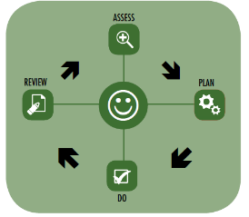

Mrs Dougan, our Learning Mentor, has been a big hit with the children – they love her, and it’s not difficult to see why! She has worked incredibly hard to build good relationships with the children, and this is clear to see in the interventions! Mrs Dougan and I carry out assessments to ensure we plan, do and review children’s progress over time. We also work closely to ensure the interventions support the academic and emotional development of children when in their classroom.
Interventions
Our interventions are detailed on the school website (https://www.stanleystpeters.co.uk/send/). Our main interventions are:
Lego Therapy – Social development programme for young people with social communication difficulties. It focuses on working as a team, developing team working skills, cooperating, social and communication interaction and the development of language skills.
Zones of Regulation– An intervention to support the development of strategies for children to be able to use to help control and regulate their emotions.
Self-Esteem– Groups to promote children’s self-esteem and confidence to develop their engagement within their classroom, work and peers.

Hello, I am the Special Education Needs and Disability Co-ordinator (SENDCo) at Stanley St Peters.
Primary school. I took over from Mrs Griffiths last year and have loved working with children
across different year groups. As SENDCo, I ensure that all staff are informed and updated about
children on the SEND register and that all understand how best to help a child with SEND. I
provide professional guidance and deliver training for all staff that support children with SEND.
I work closely with teachers, support staff and outside agencies to ensure a child's needs are met.

If you have a child with special needs and need help, please do not hesitate to ring the school office and either leave your details and I will call you back or make an appointment to meet with me. My SENDCo days are Monday and Tuesday. Please note I teach Wednesday to Friday so I am unavailable on these days.
Welcome to our termly SEND newsletter! A newsletter addressing all things related to SEND (Special Educational Needs and Disabilities). In this issue find out about the interventions that we offer in school, ideas and tips for what to do over Christmas, ways to co-regulate and important contact numbers.
The Graduated Approach
In Wakefield, we follow the graduated approach. Children who continue to face challenges in their
learning, despite receiving high-quality teaching, are likely to need additional strategies, or
different provision, in order to meet their needs. The SEND Code of Practice states that, for these
learners, teachers are required to remove barriers to learning and put effective special educational
provision in place through SEN support.

This SEN support takes the form of a four-part cycle (assess, plan, do, review). Through this cycle, actions are reviewed and refined as an understanding of a student’s needs and the support required to help them secure good outcomes increases.



Co-regulation
Gifts, advent calendars, decorations, trips to see Santa and chocolate - the Christmas that children so often love. But for some children, the festive period can be a time that makes them anxious. For all the fun they bring, the holidays also represent a break in routine, which can have an effect on a child’s emotional stability.
Co-regulation is when adults help children calm down. It’s like the training wheels for self-regulation skills, which is when children learn to cope with emotions by themselves. It provides the support, coaching, and modelling children need to “understand, express, and modulate their thoughts, feelings, and behaviours.
Here are the steps for co-regulation:
- Approach calmly. Take a deep breath yourself if needed.
- Label the child’s emotions: both the feeling and how it shows up in the body. “Hey Charlie, I see you gritting your teeth. You seem angry.” (This ties in with the emotion coaching that we do in school)
- Assist the child with finding a calming strategy, such as: taking deep, controlled breaths together, hugging a stuffed animal or trusted adult, swinging or rocking, watching objects with slow soothing movements, like a glitter jar or fish tank, chewing something appropriate like a chew toy, gum, or dried fruit and moving away from stimulus that is causing distress.
- When the child is relatively calm, try talking about what to do now. “What would you like to play with now?” “Do you want to read a book with me?”
- If there’s still a conflict that needs to be resolved, use open-ended questions. “You want to build with blocks alone and Sheila wants to build a
- store. What could we do to solve this problem?”
- If the child is still upset, repeat step three.
Co-regulation is something that most parents, family members, and teachers contribute towards. Sometimes, you might not even realise you are doing it, but you probably do it more than you think.

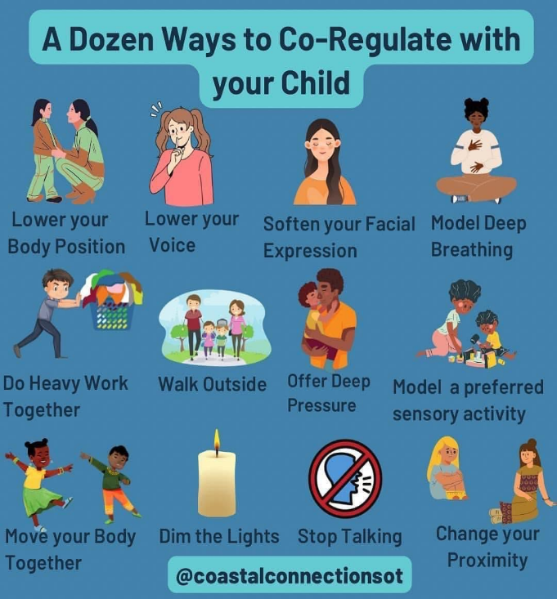
Date | Time | Event | Bookable
Friday 9th December  Friday 16th December | 3:30 - 4:30 |   Lego Club | No
Monday 19th December | 11:00 - 11:30 | Storytime | No
Tuesday 20th December |   2:30 - 3:30 |   Christmas Crafts | Yes
Thursday 22nd December | 3:30 - 4:30 | Family Games | No
Friday 23rd December | 10 am - 4 pm | Drop-In Lego | No

Events at Stanley Library

Visit Father Christmas in his cosy home at Wakefield Museum! Make your own fabulous Christmas collage, experience Christmas through the use of your senses and have fun creating all sorts of Christmassy crafts to take home with you. We have everything you need to get you into the Christmas spirit.
This session is designed for SEND families (although all children and young
people are welcome) and there will be changes to the sensory experience in the
Museum for a more relaxed visit.

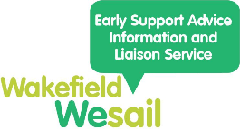


Helpful Contact Numbers
WESAIL
Wakefield Early Support, Advice, Information and Liaison (WESAIL) service provides free, confidential and impartial support for children and young people with Special Educational Needs and Disabilities (SEND) and their parents and carers. WESAIL provide information, advice, support and signposting according to need, either by telephone or where required on an individual or targeted basis or through events and workshops.
You can contact Wakefield WESAIL/SENDIASS Monday to Friday, between 9:00am
and 5:00pm.
Phone: 01924 965588
Email: wesail@family-action.org.uk
Beat Autism
A local charity providing information, support and groups for families with children and young people with autism. They offer parent support groups, activities for children with autism, help filling in benefit forms, help with blue badge and parent training courses.
Telephone Number: 07903 271785
Website: www.beatautism.co.uk/
Email: info@beatautism.co.uk
The Local Offer provides information and support available for families with children and young people ages 0-25 years with special educational needs and/or disabilities. The Local Offer aims to help people easily find information about the services, activities and support available in the local area for children and young people with Special Educational Needs and /or Disabilities and their families.
Visit the website to find out more! https://wakefield.mylocaloffer.org/

Email: SENDCO@stanleystpeters.co.uk or cschofield@stanleystpeters.co.uk

