
STANLEY ST PETER’S CE PRIMARY SCHOOL SPRING SEND NEWSLETTER
7th April 2023
Apeil 2022

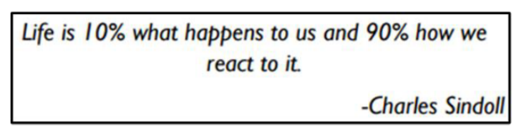
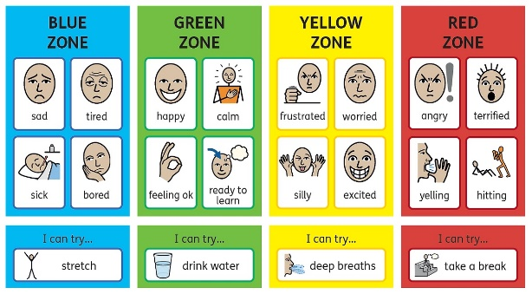
Zones of Regulation
Mrs Dougan, our Learning Mentor, runs Zones of Regulation interventions. This is an internationally renowned intervention which helps children to manage difficult emotions, known as ‘self-regulation’.
Self-regulation can go by many names such as ‘self-control’, ‘impulse management’ and ‘self-management’. Self-regulation is best described as the best state of alertness for a situation. For example, when your child takes part in a sports game, they would need to have a higher state of alertness than when, for example, they were working in a library.
From time to time, all of us (including adults) find it hard to manage strong feelings such as worry, anger, restlessness, fear or tiredness, and this stops us from getting on with our day effectively. Children who feel these emotions often find it hard to learn and concentrate in school. The Zones of Regulation aims to teach children strategies to help them cope with these feelings so they can get back to feeling calm and ready to learn.
At Stanley St Peters, we are launching the Zones of Regulation throughout the whole school. We want to teach all of our children good coping and regulation strategies so they can help themselves when they experience anxiety and stress. In the classroom, sometimes, children panic when faced with a tricky learning problem or challenge. By teaching them how to cope with these feelings might make them better at tackling learning challenges and build better resilience so they don’t give up so easily when faced with difficulty.
We want children at Stanley to grow into successful adults. Teaching children at a young age about managing their feelings will support them in later life so that they don’t turn to negative coping strategies which affect their mental and physical well-being.
We aim to help children to:
• Recognise when they are in the different Zones and learn how to change or stay in the Zone they are in.
• Increase their emotional vocabulary so they can explain how they are feeling.
• Recognise when other people are in different Zones, thus developing better empathy.
• Develop an insight into what might make them move into the different Zones.
• Understand that emotions, sensory experiences such as lack of sleep or hunger and their environment might influence which Zone they are in.
• Develop problem-solving skills and resilience
• Identify a range of calming and alerting strategies that support them (known as their personal ‘toolkit’.
Welcome to our termly SEND newsletter! A newsletter addressing all things related to SEND (Special Educational Needs and Disabilities). In this issue find out about emotion coaching and zones of regulation!
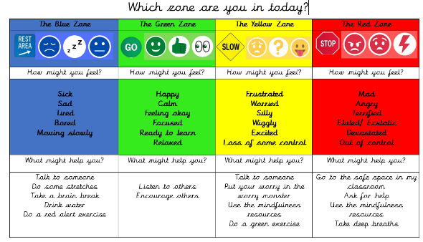

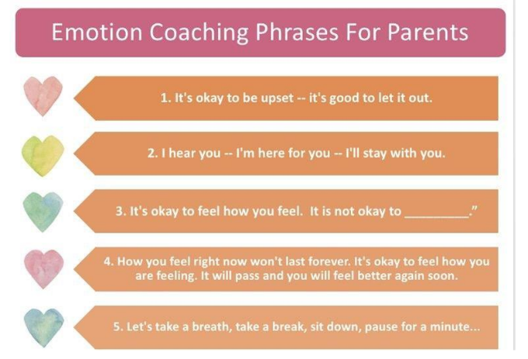
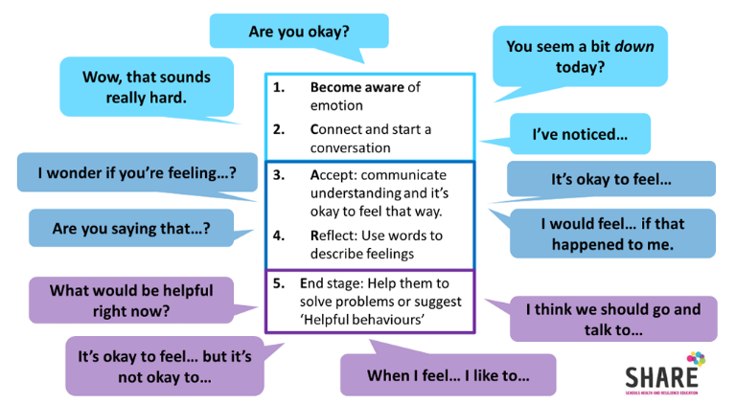
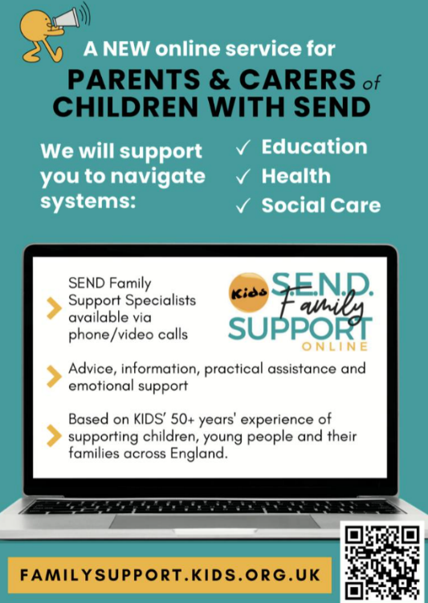
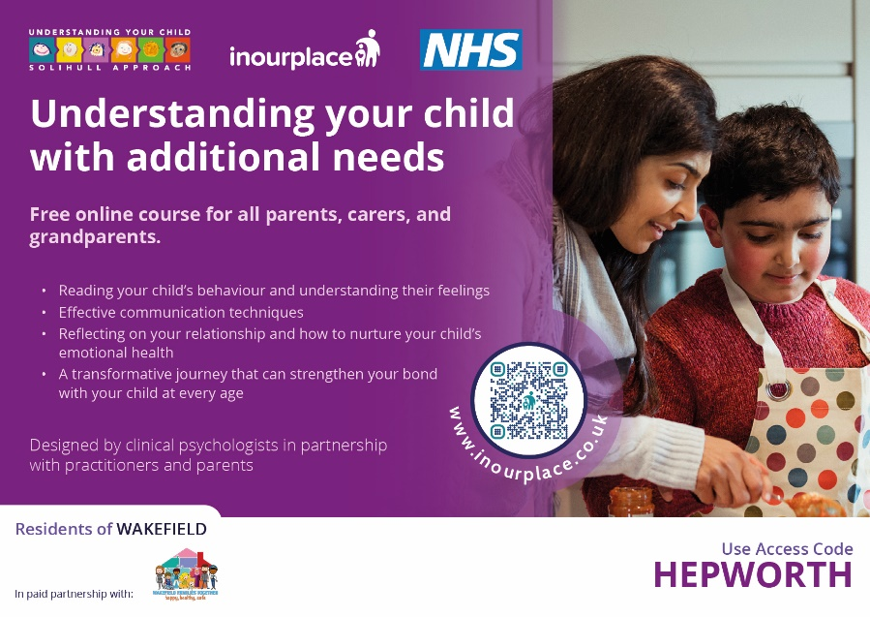

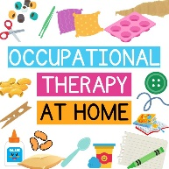
Emotion Coaching
Emotion Coaching is a practical approach that helps children and young people understand their feelings ‘in the moment’. Through Emotion Coaching, they learn how emotions work and how to react to feelings in healthy ways.
The Five Steps of Emotion Coaching
Step 1: Be aware of emotions.
The more aware you are of your feelings, the better you will understand how your child feels. When appropriate, share your emotions with your child. Children are learning about emotions by watching how you show yours. Listen to your child for clues about what she is feeling.
Step 2: Connect with your Child
Take your child’s emotions seriously. Be willing to understand your child’s perspective. Encourage your child to talk about feelings.
Step 3: Listen to your Child
Listen to your child in a way that lets her know you are paying attention. Try not to judge or criticise emotions that are different from what you expected. Research shows that it is important to understand emotions before giving advice on behaviour.
Step 4: Name emotions
Start identifying emotions even before a child can talk. Talk about emotions like happy, sad, and angry and when people feel them. Name a range of emotions. Talk about what these emotions mean and when people feel them. Avoid telling children what they ought to feel – try to identify the emotions they are feeling. Model identifying your own emotions – children learn by watching and copying what adults do. E.g. ‘I can tell you’re feeling really frustrated and angry.’
Step 5: Find solutions
When children misbehave, explain why their behaviour was inappropriate or hurtful. Encourage emotional expression, but set limits on behaviour. Help children think through possible solutions. E.g. ‘I know you feel really angry and let down but it is bedtime now. I’m going to give you a few minutes and see if you’re ready for me to help you calm down with a story / snuggle / hot drink.’
Contact are running a range of Early Years workshops for parents of children aged 0-5, covering topics such as sleep, speech and language, and early years entitlements. They are continually adding new dates, so if a workshop is not available currently, check back in a few weeks.
https://contact.org.uk/help-for-families/workshops-and-events/workshops/early-years-workshops/
Occupational therapy home programs are effective in the carryover of goal accomplishment, helping kids become more consistent with skills, and development!
Here's everything you need to know about OT at home, including a list of household
materials you can use for OT activities:
https://www.theottoolbox.com/occupational-therapy-home.../

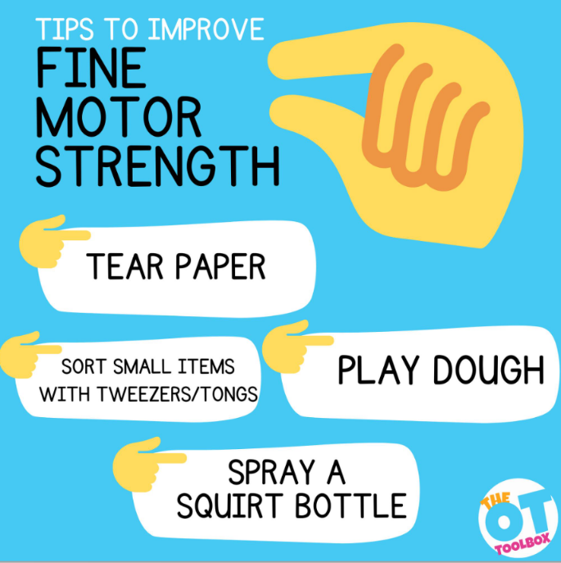
Email: cschofield@stanleystpeters.co.uk

