
STANLEY ST PETER’S CE PRIMARY SCHOOL SUMMER SEND NEWSLETTER
Summer 2023
Apeil 2022

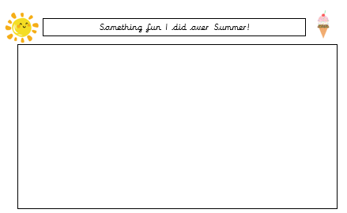
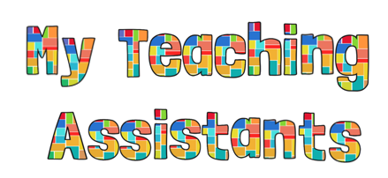
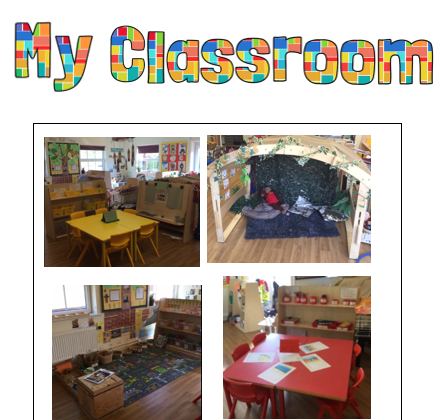
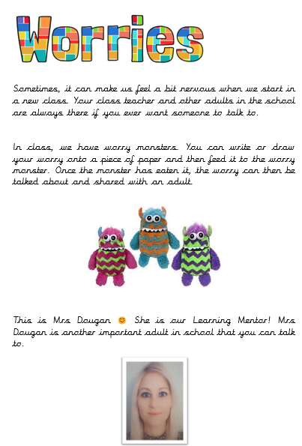
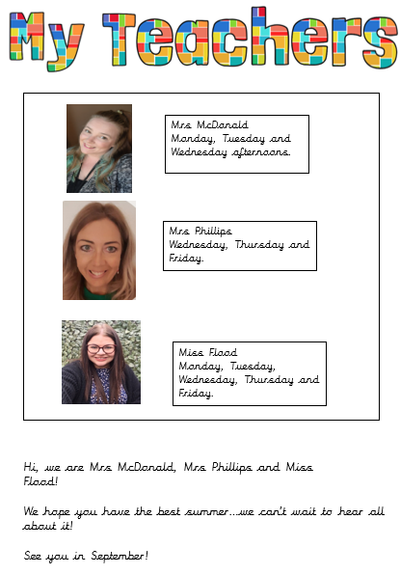

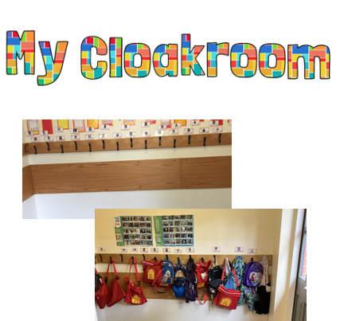
The school recently held Transition Day, which provided the children with a wonderful opportunity to meet their new class teachers and engage in a variety of activities that offered a glimpse into the exciting learning experiences ahead. From captivating science experiments to engaging group activities, the day was filled with laughter, curiosity, and anticipation.

Recognising the importance of ensuring a smooth transition for all students, we provided Transition Booklets tailored specifically for our SEND children. These booklets contain valuable information, including pictures and details about their new classroom, teacher, and teaching assistant, along with enjoyable optional activities designed to make the transition process enjoyable and enriching.

Welcome to our termly SEND newsletter! A newsletter addressing all things related to SEND (Special Educational Needs and Disabilities). In this issue find out about how we can help children prepare for change, cope with change when it comes, and even embrace the benefits of new experiences.
Summer is the season for change – with the long holidays sending school and usual routines out the window, followed by a new academic year when children are expected to fit neatly back into those routines again. September may also bring a new teacher, a new classroom and, for some children, new classes, new subjects and even a new school.
So how do parents of children with SEND help their children manage the changes that the next few months will bring?

Six weeks, six tips: Building change into the holidays

Consider holding onto some routine while being adaptable
The last few days of the summer term are likely to have been a bit different to normal days at school, which should help ease the transition into the holidays. If your child craves routine, incorporate some of your usual activities into the first few weeks of the summer holidays. This might be getting up at the same time or even eating a packed lunch.
Every child is different, and some children may be happy to say goodbye to school for a few weeks as soon as the clock hits 3:30 pm on the last day of term. Others may gradually want to reduce the number of term-time routines they keep in place over the holidays, while some may want to keep them running all the way through. Whatever course your child takes, it’s useful to start incorporating some of the school routines back into life in the last week or so of the holidays so that it’s not too much of a shock when school starts again in September.

Get talking
Use prompt questions to initiate conversations about change and transition and what your child might like to do over the summer holidays. Let them be involved in making plans – this will help them to feel they have some control over events. In terms of starting a new class, sometimes children won’t know what they don’t know – there might be issues around change that they haven’t thought about yet. While it’s great that they aren’t feeling worried about change and transition, gently asking a few probing questions to get them thinking ahead to September might help ease the way once you get there.

Have plans for the first week
The first week of the summer holidays is the most crucial – start off well, and it will set the mood for the rest of the holidays. The first few days of a change in routine or setting are always the most difficult for children who need help to adapt, so make sure the first week includes some routine and some of your child’s favourite things to allay any fears.

Keep up with friends over the summer
Seeing familiar faces outside of school will not only help your child to stay connected to friends so that the relationships are still there in September but will also help to build bridges between school and the long summer holidays.

Keep a record
Encourage your child to keep a record of what they’re doing during the summer holiday to show to their teacher and TAs when they return to school, a holiday scrapbook for example. As well as helping your child to keep busy and continue developing their skills over the holidays, this will help them keep in mind that the holidays are only for a finite period of time and that they will be going back to school soon.

Don’t feel you have to fill every moment
It can be easy, with a child who craves routine, to feel that you have to fill every moment of the holiday with activities but remember that children need downtime too. You know your child best – whether they’d prefer short stop-gaps of downtime in-between bursts of activity, or day-long pyjama days when they (and hopefully sometimes you!) can drift through the hours enjoying no restraints, timetables or demands.

September’s coming…
It’ll be typical that your child (and you) will have just found your stride and be relaxing into summer when, all of a sudden, it’s time to start thinking about going back to school!

To avoid September shock:
Gradually build up to returning to school as the weeks go by. Bring it (casually) into conversation often to remind your child that it’s on the horizon. If your child is feeling anxious about returning to school, talk through their transition packs or complete activities in the back of their booklets.
Intersperse school provision shopping throughout the holidays – perhaps for uniform one week, school shoes the next and stationery the following week. Not only will this make back-to-school shopping more manageable but it’ll also help consolidate in your child’s mind that they are going back to school soon. Letting them choose their stationery, and perhaps a new school bag will give them ownership over going back to school and help them feel they have some control.

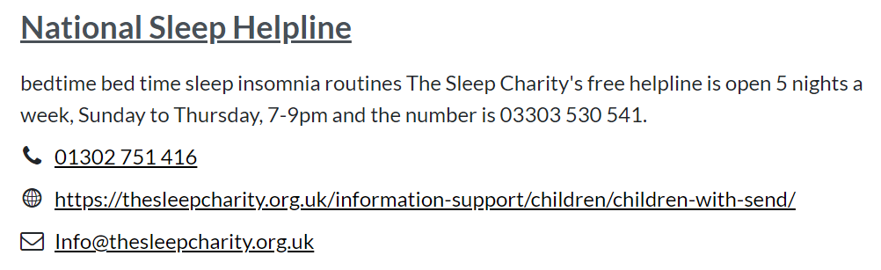
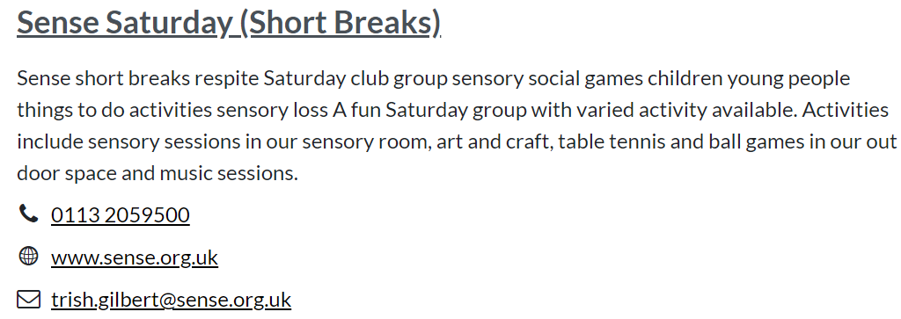
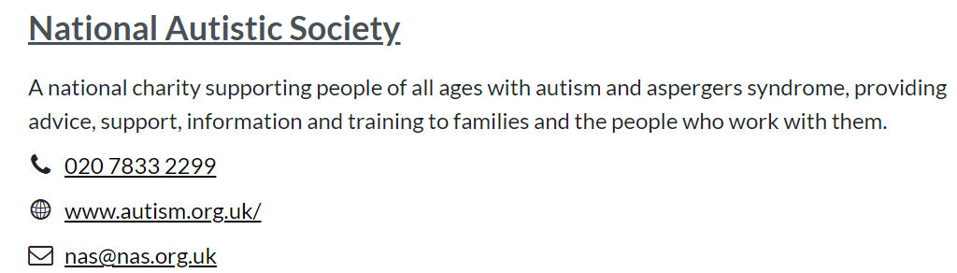
Contacts
Email: cschofield@stanleystpeters.co.uk

