
STANLEY ST PETER’S CE PRIMARY SCHOOL AUTUMN SEND NEWSLETTER
December 2023
Apeil 2022


At Stanley St Peters, we are VERY fortunate to have an AMAZING learning mentor, Mrs Dougan (known as Mrs D to all of the children!). Mrs D does weekly check-ins with children and a range of interventions, which can be found below. The children love going to visit her room to see and feed the fish!
Hello, I am the Special Education Needs and Disability Co-ordinator (SENDCo) at Stanley St Peters.
Primary school. If you have a child with special needs and need help, please do not hesitate to ring the school office and either leave your details and I will call you back or make an appointment to meet with me. My SENDCo days are Monday and Tuesday. Please note that I teach Wednesday to Friday so am unavailable on these days.
Welcome to our termly SEND newsletter! A newsletter addressing all things related to SEND (Special Educational Needs and Disabilities). In this issue, find out about the interventions that we offer in school, new investments and training and important contact numbers.
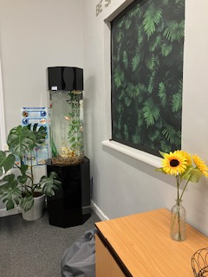
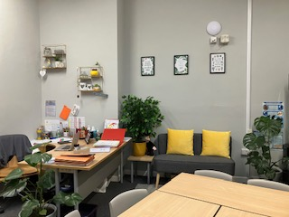
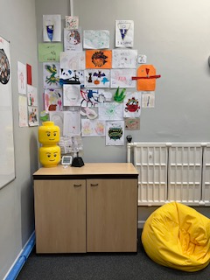

Interventions
Lego Therapy – A social development programme for young people with social communication difficulties. It focuses on working as a team, developing teamwork skills, cooperating, social and communication interaction and developing language skills.
Zones of Regulation– An intervention to support the development of strategies for children to be able to use to help control and regulate their emotions.
Self-Esteem– Promotes children’s self-esteem and confidence to develop their engagement within their classroom, work and peers.
Developing Friendship skills – An intervention that covers what makes a good friend, helps children develop cognitive and social-emotional skills and helps children learn how to express how they feel to others and be considerate of others' feelings.
Emotions & Feelings – This intervention focuses on enhancing awareness and understanding of various emotions and feelings. Children learn valuable skills for effective emotional expression and management through targeted activities.
Social stories - Social Stories demonstrate appropriate social interaction, re-enacting different situations using social cues and recommended responses.
Turn-taking - Sharing and turn-taking impart vital life skills. This intervention teaches children about fairness, compromise and how to negotiate with others and manage disappointment.

Turn Taking –
Social Stories -

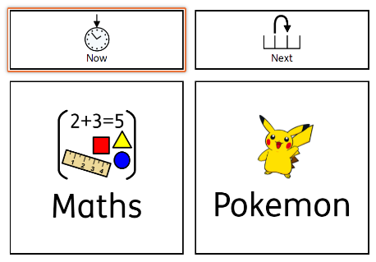
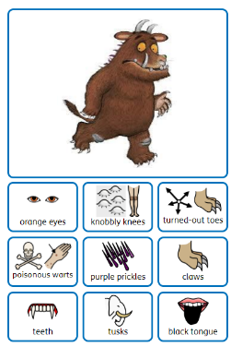
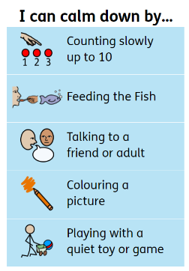
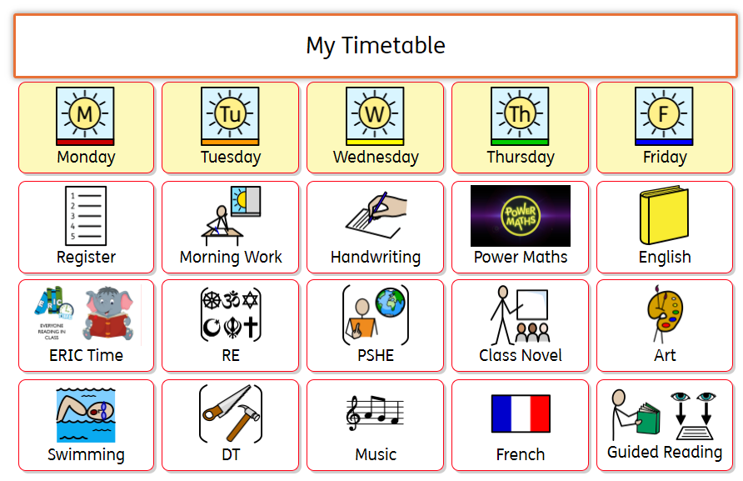
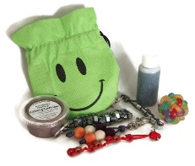
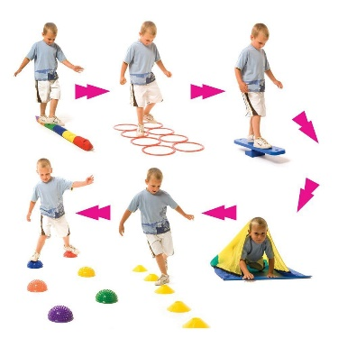
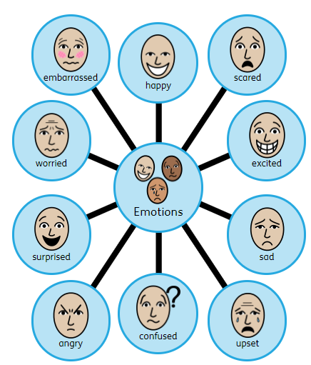
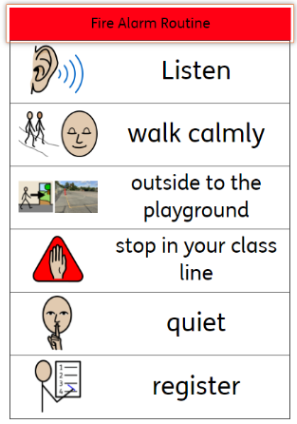
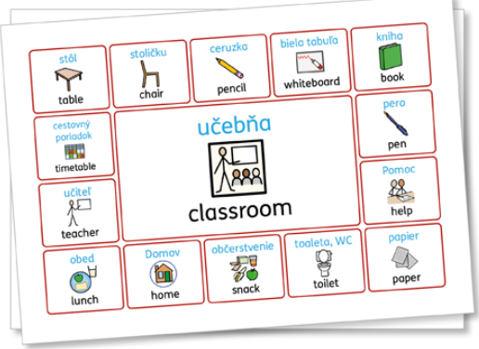

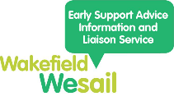
Children access movement and sensory breaks to help them regulate.

We are thrilled to share with you that we have recently invested in Widgit symbols. These symbols are designed to play a crucial role in supporting communication for various aspects, including routines, behaviour and introducing new vocabulary. We aim to ensure that every child has a voice and can seamlessly access the world around them.
Widgit symbols are particularly beneficial for all children as they navigate and adapt to their daily routines. This additional support is especially crucial for those facing challenges in reading or language, as it can sometimes be more difficult for them to communicate and access learning materials. We believe that with the integration of Widgit symbols, we can create an inclusive and supportive environment for all children to thrive.
Autism Education Trust
The Autism Education Trust (AET) is a non-profit programme led by two national autism charities – the National Autistic Society and Ambitious about Autism. Established and supported by the Department for Education, the AET promotes and supports partnerships throughout the education system to improve educational access, experience and outcomes for autistic children and young people.
According to the latest SEND statistics from the Department for Education, which are based on the school census, there are over 160,000 autistic pupils in schools across England. Wakefield Council is now a partner with the Autism Education Trust. Their vision is to improve life chances and improve the quality of education for autistic pupils across the UK.
We were lucky enough to attend training from the AET during the summer term
and will be completing the follow-on module ‘Good autism practice’ during the
spring term.
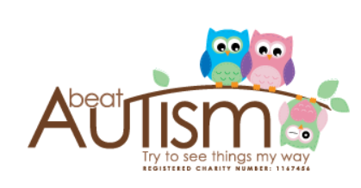
Contacts
Beat Autism
A local charity providing information, support and groups for families with children and young people with autism. Beat Autism also runs groups for children and young people.
07903 271785 https://www.beatautism.co.uk/ beatautismuk@aol.com
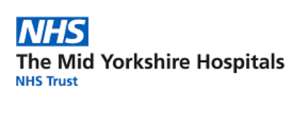
Children's Occupational Therapy
Occupational therapy training encompasses a range of elements, including addressing sensory issues, providing training for parents and carers, offering free online courses, facilitating referrals, and sharing informative YouTube videos for both parents and carers. The training covers diverse topics, such as sensory sleep, toilet training, and the neuroscience of sensory processing. Additionally, it delves into understanding the link between anxiety, focus, and self-regulation. The sessions aim to equip individuals with practical skills to manage everyday activities such as toileting, getting dressed, sleep routines, and meal times.
01924 541411 midyorks.asccoordinators@nhs.net
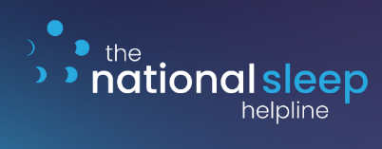
National Sleep Helpline
Bedtime, sleep, insomnia and routines. The Sleep Charity's free helpline is open 5 nights a week, Sunday to Thursday, 7-9pm and the number is 03303 530 541.
https://thesleepcharity.org.uk/information-support/children/children-with-send/
Info@thesleepcharity.org.uk
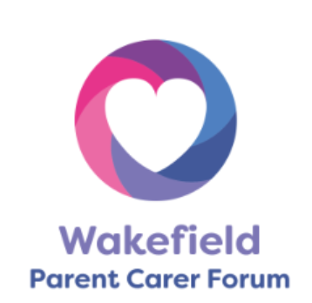
Wakefield Parent Carer Forum
Wakefield Parent Carer Forum is an independent parent-led forum that works with families of children with special educational needs and/or disability aged 0-25 years old living in the Wakefield area. You can find out more by visiting the Wakefield Parent Carer Forum page on the Local Offer.
www.wakefieldparentcarers.co.uk
info@wakefieldparentcarers.co.uk


Buzz (Compass)
Buzz is an emotional and well-being support service. Buzz offers short-term support to children and young people in the Wakefield district. Issues children and young people might have that can be supported are low mood, anxiety, managing emotions, bullying, friendship problems, loneliness and sadness. Children and young people can text 'Buzz' to 85258 for help. The Compass charity runs the service.
(Text) 85258 https://www.compass-uk.org/ info@compass-uk.org
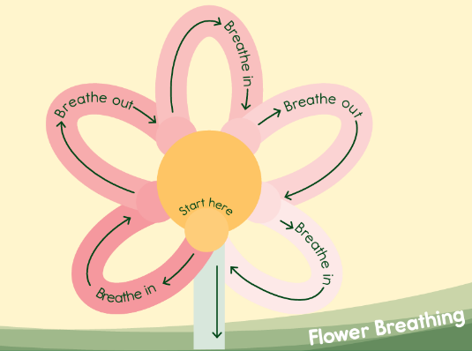
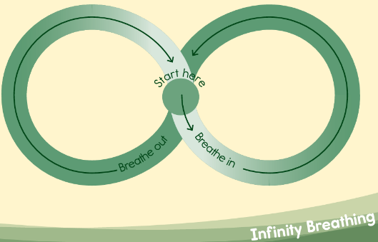
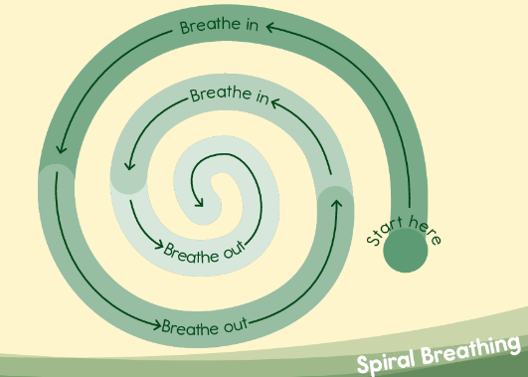
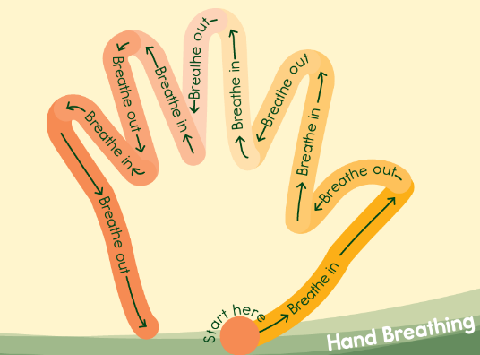
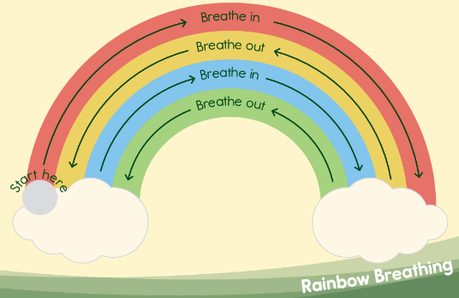
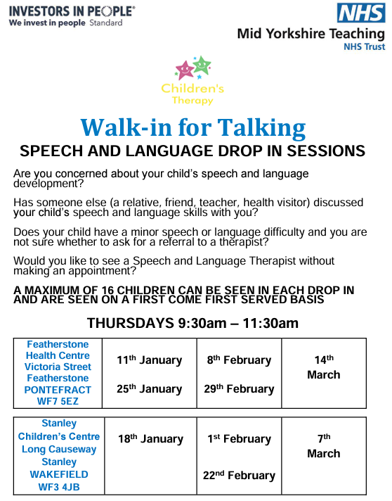
Events at Stanley Library

Email: cschofield@stanleystpeters.co.uk

Day | Time | Event | Booking required?
Every Friday | 3:30 - 4:30 |   Lego Club | No
Every Monday | 11:00 - 11:30 | Storytime (under 5’s) | No
Every Saturday | 10:30 - 11:30 | Saturday Family Crafts | No

Breathing Techniques

