
STANLEY ST PETER’S CE PRIMARY SCHOOL SPRING SEND NEWSLETTER
March 2024
Apeil 2022


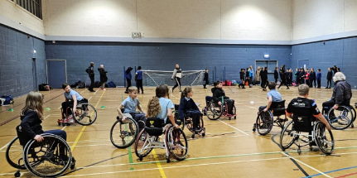

Mrs. D and I recently accompanied some of our children to a SEND sporting event at Featherstone Sports Centre where we engaged in wheelchair basketball! It was an absolute blast as we honed our skills under the guidance of Steve, the fantastic coach from Wakefield Whirlwind Wheelchair Basketball Club.
Hello, I am the Special Education Needs and Disability Co-ordinator (SENDCo) at Stanley St Peters.
Primary school. If you have a child with special needs and need help, please do not hesitate to ring the school office and either leave your details and I will call you back or make an appointment to meet with me. My SENDCo days are Monday and Tuesday. Please note that I teach Wednesday to Friday so am unavailable on these days.
Welcome to our termly SEND newsletter! A newsletter addressing all things related to SEND (Special Educational Needs and Disabilities). In this issue, find out about Musical Interaction, trips and important contact numbers.
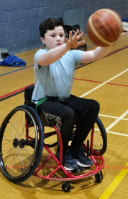
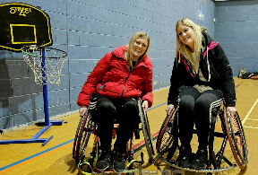
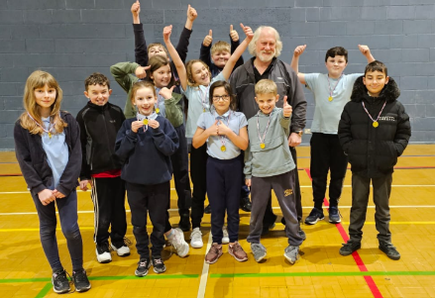
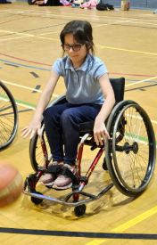

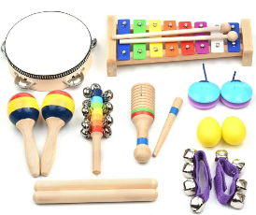
Musical Interaction
Mrs. Dougan and I recently attended a fantastic Musical Interaction training session. It was jam-packed with amazing ideas to make our sessions with the children even more enjoyable and engaging!
Musical Interaction is an approach in which music and props are used to engage children through fun, familiar experiences and song. It enables children to express their emotions and their personality through musical play whilst also developing fundamental social and communication skills.
The aims of Musical Interaction are:
· To enjoy and engage in an experience of shared play and fun with a familiar person.
· To develop communication skills, such as eye contact, turn-taking, imitation and initiating
interaction, at a level appropriate to the individual’s need.

· To develop the use of pre-verbal conversational skills such as shared attention, use of eye contact, imitation, anticipation and turn-taking which provide the framework for later social communication.
· To develop rewarding and reciprocal relationships.
· For children to develop an awareness of themselves, make choices and communicate their views.
· To develop conversation and social ‘flow’, e.g. recognising when to take a turn or when to initiate an interaction.
· To promote a child's self-awareness, choice-making, self-esteem and general emotional well-being

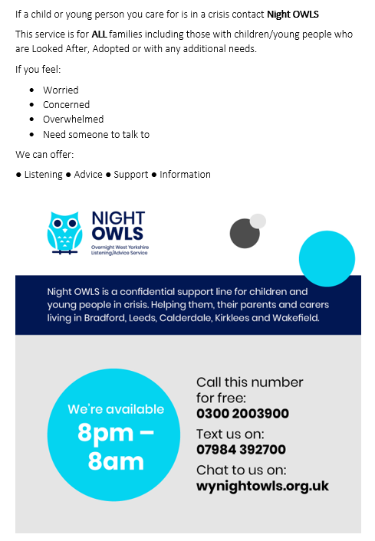
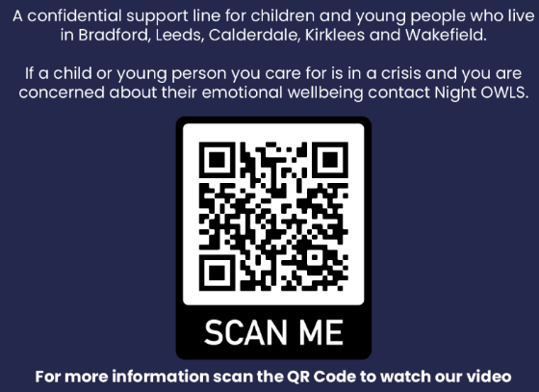
Night OWLS can help you if you:

- Feel you have nowhere to turn
- Feel you can’t go on living
- Are in a crisis
- Are finding it hard to cope with life
- Are feeling angry, lonely, anxious or depressed
- Are feeling confused or finding it hard to think straight
- Are feeling unsafe
- Are caring for a young person
- Just want to talk

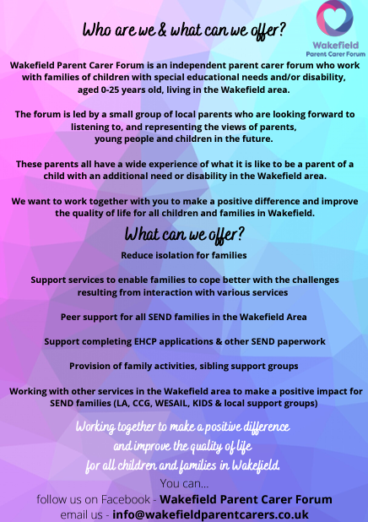
Keep up with their latest events on their website: https://www.wakefieldparentcarers.co.uk/events Be a part of the SEND Gaming Club, join the coffee mornings or visit the soft play sessions!
What can they help with?
- Occupational Therapy Pathway
- ASD Strategic Group New Ways of Working/Wakefield Families Together
-Help families read, understand & action letters from hospital, school, the LA or any other professional
-Help parents complete requests for EHCP needs assessments
-Signpost families into services such as Barnardo’s WESAIL
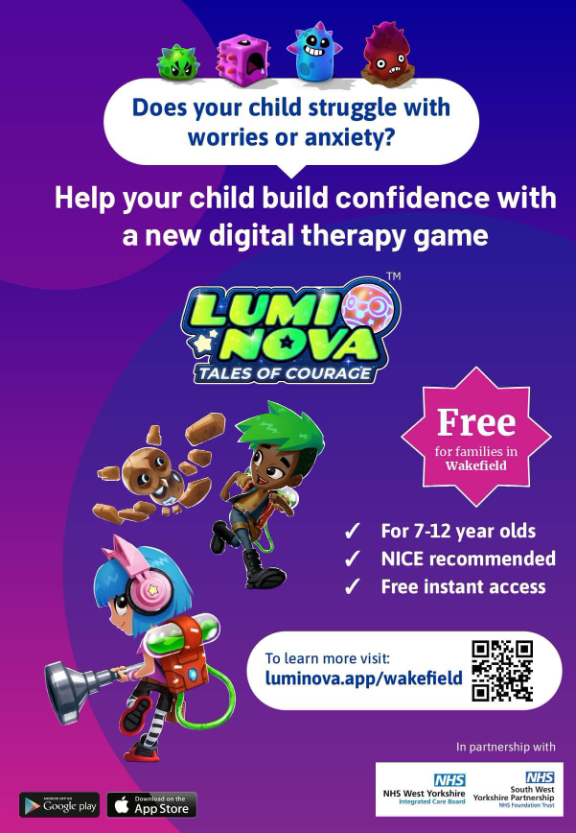
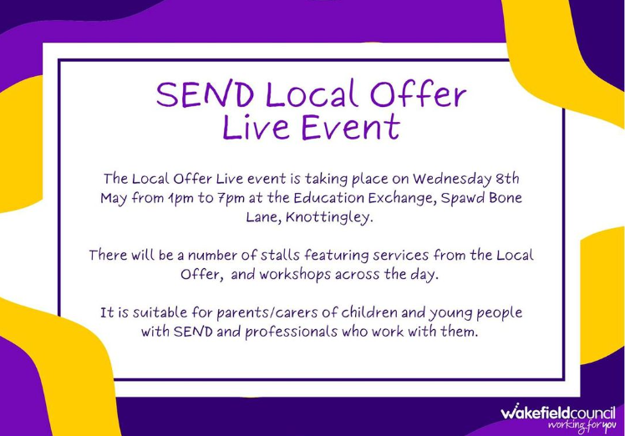
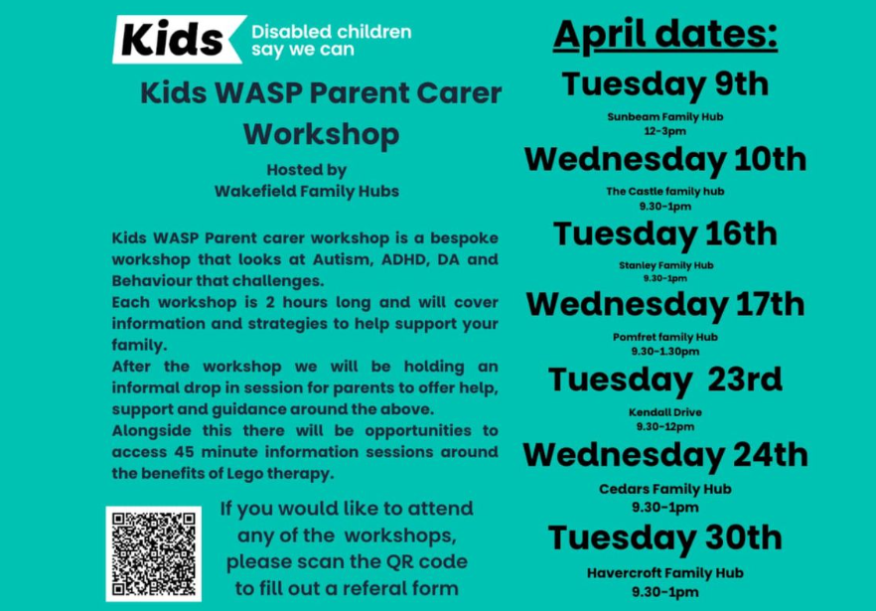
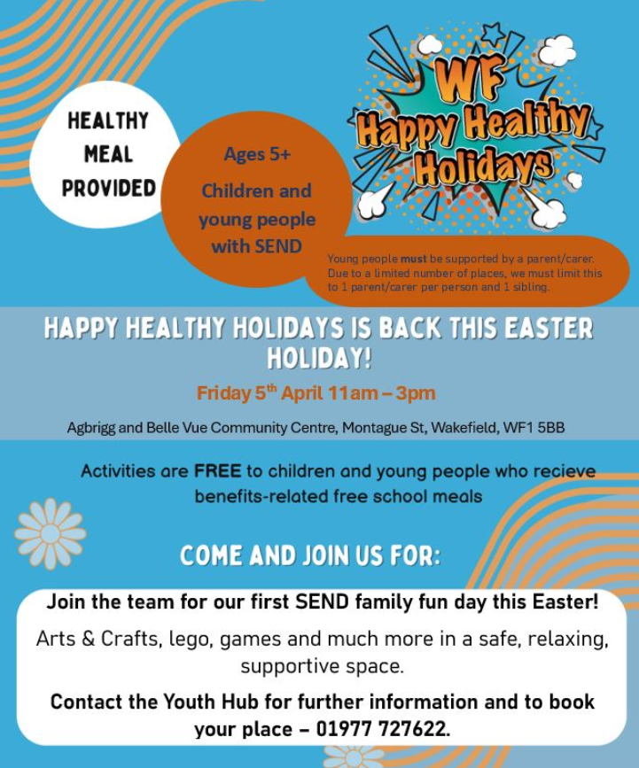
Wakefield Awareness Support Project (WASP) is funded by Wakefield CCG and is delivered by KIDS. WASP is unique in its approach to supporting families of young people either on the Autistic Spectrum (diagnosed or under investigation) or who have other neuro-developmental conditions. WASP offers two distinct elements which work in collaboration with each other to support both the parents/carers and the young person with a bespoke package of support.

Email: cschofield@stanleystpeters.co.uk

