
STANLEY ST PETER’S CE PRIMARY SCHOOL SPRING SEND NEWSLETTER
July 2024
Apeil 2022

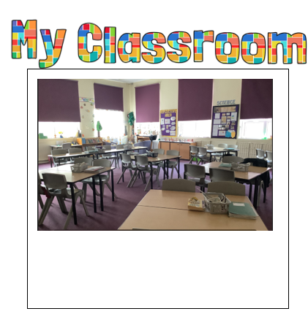
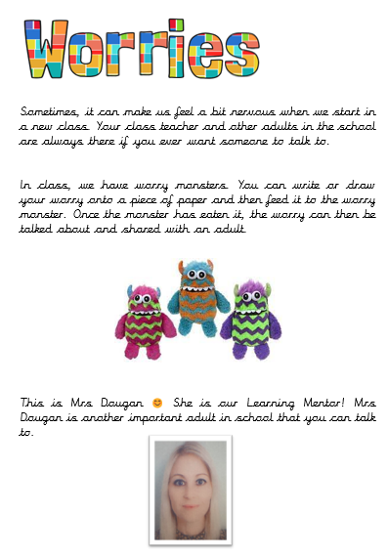



SEND Transition Booklets – Supporting a Smooth Start
All SEND children received a transition booklet to help them feel comfortable and confident about their new school year. Each booklet includes a page introducing their new teacher, photos of their teaching assistant, classroom, playground, dining area, and cloakroom. It also provides guidance on what to do if they have any worries and includes fun activities to enjoy over the summer.
Transition booklets are an important way to help children prepare for changes, reduce anxiety, and build excitement for their return to school. By becoming familiar with their new environment and routines, children can feel more settled and ready to learn in September.
We hope everyone has a wonderful summer break, and we can’t wait to welcome all the children back in September!

Hello, I am the Special Education Needs and Disability Co-ordinator (SENDCo) at Stanley St Peters.
Primary school. If you have a child with special needs and need help, please do not hesitate to ring the school office and either leave your details and I will call you back or make an appointment to meet with me. My SENDCo days are Monday and Tuesday. Please note that I teach Wednesday to Friday so am unavailable on these days.

As we approach the summer holidays, we want to take a moment to celebrate the progress and achievements of all our SEND children this year. We are incredibly proud of their hard work, resilience and growth. A huge thank-you to you, our parents and carers, for your continued support and partnership.

Welcome to our termly SEND newsletter! A newsletter addressing all things related to SEND (Special Educational Needs and Disabilities). In this issue, find out about transition booklets, new Wakefield offers and important contact numbers.
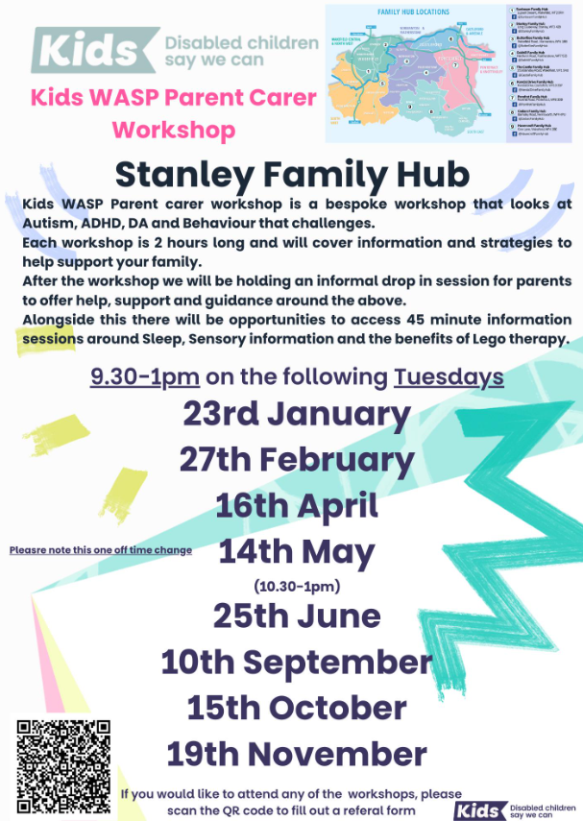
WASP offers tailored support for children, young people, and their families who may be experiencing challenges with social interactions, communication or neuro-developmental needs – no diagnosis needed.
Their Participation Coordinator connects with families to understand their needs and personalise the support they offer.
For parents, this could include regular check-ins, Expert Parent training, and online courses. They also encourage peer-to-peer support, giving parents the chance to connect with others who’ve had similar experiences. The aim is to help parents build resilience and confidence to support their child’s journey.
They offer activities like Lego Therapy and Big Life Journal sessions to boost self-esteem and resilience and help with transitions for children and young people.


What’s New on Wakefield’s Local Offer?

Service – support and workshops for parents and carers of autistic children and young people.

Relaxed Openings Wakefield Museum
These are adapted sessions at the museums to support sensory needs.

Additional needs streetdance classes.
The below groups and places all offer evening or weekend sessions. Visit their page on the Local Offer or contact them directly for more information.
Cloud 9
Age: 0 - 10
The Old Auction House, Illingworth Street, Ossett, Wakefield
Phone: 07396 688866
Website: https://cloud9ossett.co.uk/

Elephant Club
Age: 0 - 7
Wild At Heart Stay & Play Room, 13, The Precinct Station Lane, Featherstone, Pontefract, WF7 5BX
Email: wildatheartsap@gmail.com
Website: https://www.facebook.com/wildatheartstayandpla

Flexi Totz Gymnastics
Age: 3 - 7
Unit 8, Skinner Lane, Pontefract, WF8 1HG
Phone: 07307 614141
Email: flexitotz@gmail.com
Website: https://flexi-totz.classforkids.io

Gravity
Age: 18 months upwards
Castleford Xscape, Colorado Way, Castleford, WF10 4TA
Phone: 01977 529920
Website: https://gravity-global.com/active/activities/sen-sessions

Growing Works
Age: 0 - 12
Crow Nest Park, Heckmondwike Rd, Dewsbury, WF13 2SG
Phone: 07883 905899
Email: info@growingworks.org.uk
Website: http://www.growingworks.org.uk

Little Fishes Soft Play
Hemsworth Methodist Church, Westfield Road, Hemsworth, WF9 4PU
Email: Littlefisheshemsworth@outlook.com
Website: https://www.littlefisheshemsworth.com

NLY Community Sport
Age: 6 - adult
Crofton Community Centre, Wakefield, WF4 1LD
Phone: 07842 903018
Email: info@nonleagueyorkshire.com
Website: https://www.nonleagueyorkshire.com/disability-football

Normanton Sports Acro
Age: 18 months to adult
152 Castleford Road, Normanton, WF6 2EP
Phone: 07773 704735
Email: normantonsportsacro@googlemail.com
Website: https://www.facebook.com/people/Normanton-Sports-Acro/100064813983561
11

Run Riot (The Old Quarry Adventure Playground)
Age: 5 - 25
93 Sycamore Avenue, Knottingley, West Yorkshire, WF11 0PJ
Phone: 01977 670953
Email: hollycorbettoqap@outlook.com
Website: https://www.theaddy.org

Sensory Planet
Age: any
A1 Business Park, Knottingley, WF11 0BU
Phone: 01709 919036
Email: knottingley@sensoryplanet.co.uk
Website: https://sensoryplanet.co.uk

Snowzone Disability Sports
Snozone, Colorado Way, Castleford, West Yorkshire, WF10 4TA
Phone: 0333 0030 520
Email: enquiriesyorkshire@snozoneuk.com
Website: https://snozoneuk.com/disabilitysnowsports

Stride Theatre
Age: 1 - adult
Ridings Shopping Centre, Unit 10, Almshouse Lane, Wakefield, WF1 1DS
Phone: 01924 806024
Email: rebecca@stridetheatre.co.uk
Website: https://www.stridetheatre.co.uk

Thornes Juniors Football Club
Age: 6 - 16
Queens Drive (Near Holiday Inn),, WF5 9BE
Phone: Pete - 07516 306163
Email: thornesjfc@gmail.com
Website: https://www.pitchero.com/clubs/thornesjuniorsfc/

Thornes Park Stadium – Bicycle Hire
Thornes Park Athletics Stadium, Wakefield, WF2 8TY
Phone: 01924 369631
Email: thornesas@wakefield.gov.uk
Website: https://www.wakefield.gov.uk/sportsand-leisure/sport-activities-and-classes/disability-sport-and-fitness

Wakefield Parent Carer Forum (WPCF)
SEND soft play, children’s craft sessions, LEGO club and gaming club.
Unit 2, Airedale Business Centre, Kershaw Avenue, Castleford, WF10 3ES
Email: info@wakefieldparentcarers.co.uk
Website: www.wakefieldparentcarers.co.uk

Email: cschofield@stanleystpeters.co.uk

