
STANLEY ST PETER’S CE PRIMARY SCHOOL SPRING SEND NEWSLETTER
December 2024
Apeil 2022

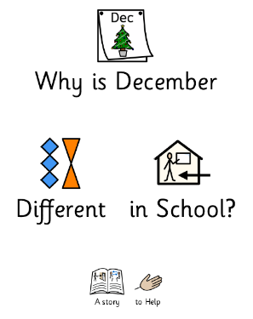
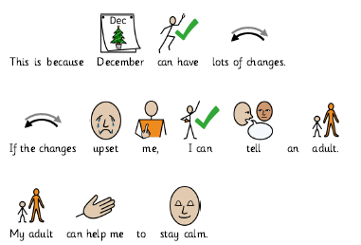
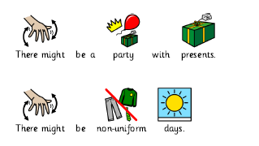
Supporting Our SEND Children During the Festive Season
We understand that the Christmas period can be a challenging and overwhelming time for some of our children. The changes to routines, exciting but unfamiliar activities and festive events can sometimes feel unsettling.
To help our SEND children prepare for these changes, we have shared a social story explaining why December is different at school. This story outlines what they can expect, from special activities to adjusted timetables, helping them feel more comfortable and prepared for the festive period.
We encourage you to continue these conversations at home, using the social story as a guide to talk about upcoming events and routines. If you would like a copy of the story or additional resources to support your child, please let us know.
Our goal is to ensure that all children feel safe, supported, and included during this special time of year.

As we come to the end of the autumn term, we want to take a moment to recognise and celebrate the progress our SEND children have made over the past few months. Whether they’ve mastered new skills, grown in confidence or settled into new routines, we are incredibly proud of their hard work and determination.

We also want to thank you, our parents and carers, for your continued support and partnership this term. Your involvement and encouragement have played a vital role in helping your children thrive.

We understand that the Christmas period can bring changes in routine, which may feel challenging for some children. If you would like any support or resources to help your child during the holidays, please don’t hesitate to reach out.

Wishing you and your family a restful, joyful Christmas and a happy, healthy New Year. We look forward to seeing you in January for another exciting term of learning and growth.
Welcome to our termly SEND newsletter! A newsletter addressing all things related to SEND (Special Educational Needs and Disabilities). In this issue, find out about social stories, strategies for coping with change at home and WASP coffee mornings.

Positive Feedback on WASP Workshops
We are thrilled to hear such positive feedback from parents who have attended the WASP sessions we recommended. Many parents have shared how valuable these workshops have been—not only for gaining practical advice from professionals but also for connecting with other parents and carers who share similar experiences.
The sessions offer a supportive space to share ideas, ask questions and learn helpful strategies to support your child’s needs both at home and in the community.
We are so pleased that many of you have found these workshops beneficial, and we will continue to share opportunities like this that may support you and your family.
If you’d like more information about upcoming WASP sessions or other resources, please let us know. We’re always happy to help you find support that makes a difference.

Supporting Differences in Routine at Home
We understand that changes in routine, especially during the festive period, can be challenging for some children. To help with this, we have provided a table of practical suggestions that you can use at home to support your child through these changes. These strategies can help your child feel more prepared, comfortable and secure during periods of transition.
Every child is different, so feel free to adapt the ideas to suit your family’s needs. If you would like any further support or guidance in putting these strategies into place, please don’t hesitate to contact us. We are always happy to help you find approaches that work best for your child.
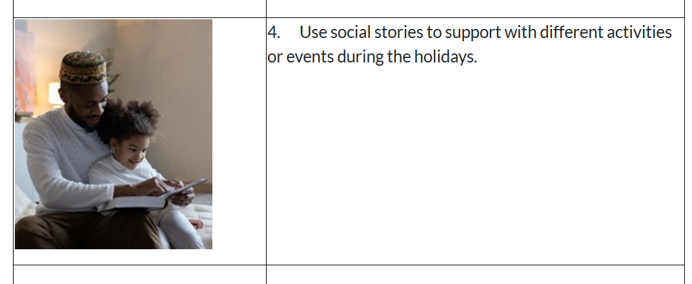
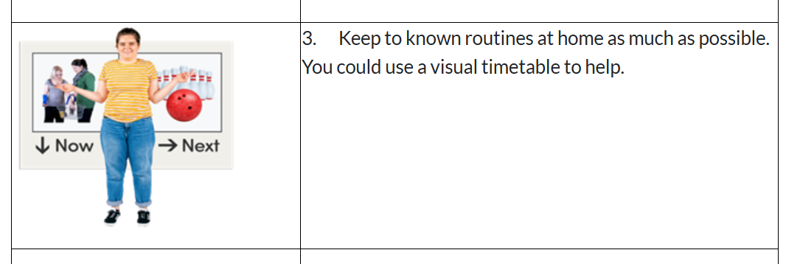
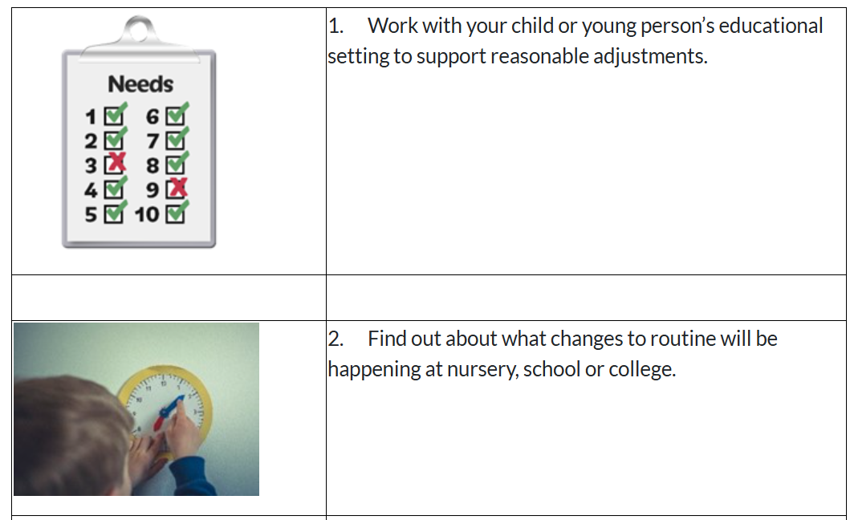
Email: cschofield@stanleystpeters.co.uk
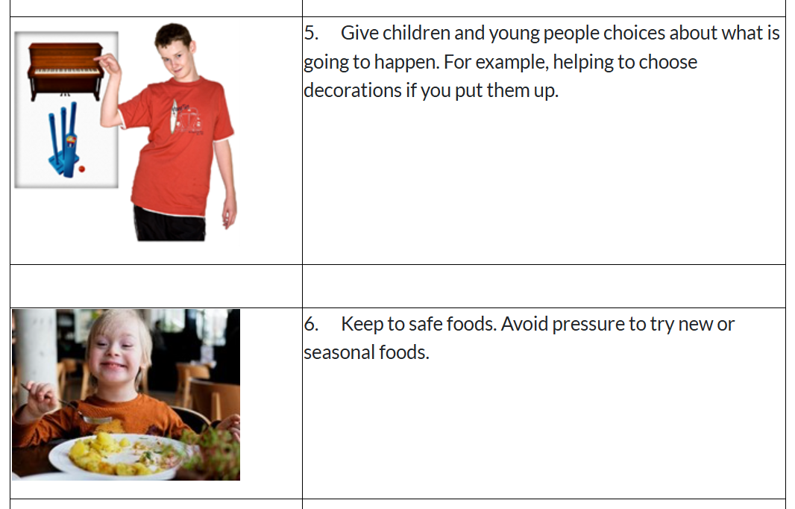
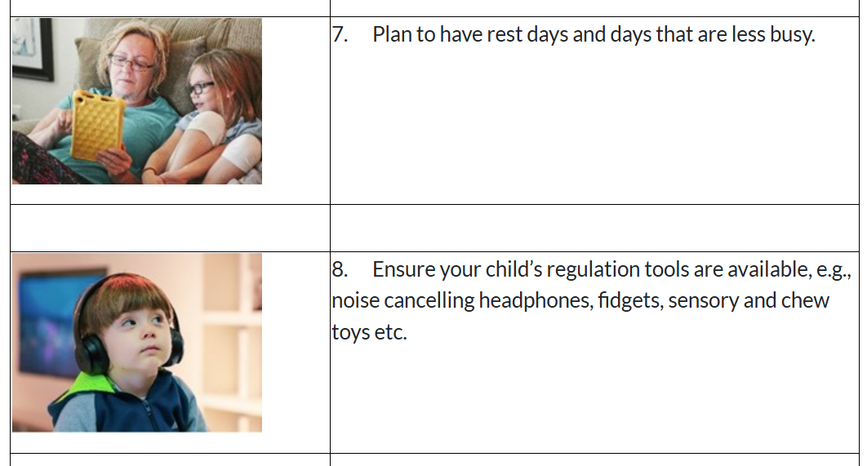

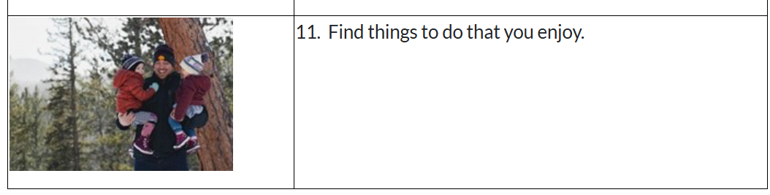
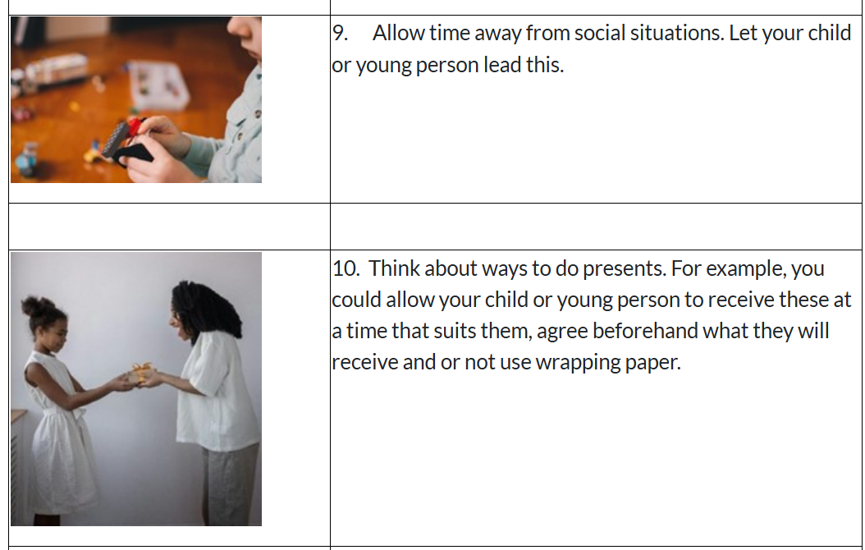
Wakefield’s Local Offer – Support for SEND Families
The Wakefield Local Offer is an online resource designed to support children and young people with special educational needs and disabilities (SEND), as well as their families. It provides a wealth of information about local services, including education, health, social care, and community support. Whether you’re looking for specialist advice, activities, or guidance on accessing services, the Local Offer can help you find the right support for your child.
You can explore the Wakefield Local Offer online to see what is available in your area. If you need any help navigating the site or finding specific resources, please don’t hesitate to reach out—we’re happy to support you.
https://wakefield.mylocaloffer.org/

