
STANLEY ST PETER’S CE PRIMARY SCHOOL AUTUMN SEND NEWSLETTER
December 2025
Apeil 2022

Email: cschofield@stanleystpeters.co.uk
Welcome to our termly SEND newsletter! A newsletter addressing all things related to SEND (Special Educational Needs and Disabilities).
As we reach the end of the autumn term, we would like to reflect on the many positive steps our SEND pupils have taken this term. We have seen children develop new skills, grow in confidence and resilience and make progress in ways that are meaningful to them. We are especially proud of how hard our pupils have worked, often overcoming challenges with determination and courage.

This term has also seen the opening of The Bridge, our new provision designed to support learners who may find accessing learning in the classroom more challenging at times. The Bridge provides a supportive, structured space that helps pupils regulate, re-engage and develop the skills they need to successfully reconnect with classroom learning. It has already had a positive impact on pupils’ confidence and readiness to learn.

We were delighted to welcome parents and carers to an ADHD training session delivered by our SEND Governor, Karen Hopwood. The session provided clear, practical guidance on understanding ADHD, including how it can affect attention, behaviour, emotional regulation and learning both at home and in school. Karen shared a range of helpful strategies to support children positively, alongside valuable insights into recognising strengths and celebrating individuality. The session also offered a supportive space for parents and carers to ask questions, share experiences and connect with others who face similar challenges, which many attendees found reassuring and empowering. Feedback from families was extremely positive, with parents commenting on how informative, welcoming and reassuring the session was.

We are also pleased to have welcomed Chatterbugs into school this term. This new speech and language service is supporting pupils to develop their communication skills, which are essential for learning, social interaction and emotional wellbeing. Early and targeted support in this area can make a significant difference to children’s confidence, independence and long-term progress.

We would like to thank our parents and carers for your continued support and partnership. Your involvement plays a vital role in helping our children feel understood, supported and successful. As the Christmas period can bring changes to routines, please remember that support and advice are available should you need them during the holidays.

We wish you and your families a peaceful and joyful Christmas and a happy, healthy New Year. We look forward to welcoming everyone back in January for another term of learning, growth and success.

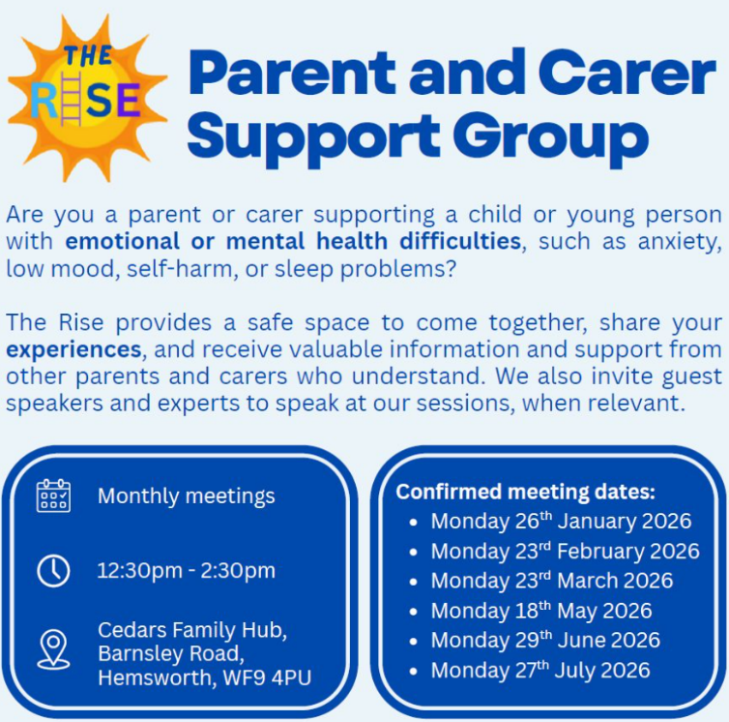

Boundless Buddies
I would also like to share some wonderful feedback from families who have attended Boundless Buddies, a term-time club run at Christ Church, Lofthouse. Parents have told us how welcoming, inclusive and supportive the sessions are, and how much their children enjoy having a safe space where they can build confidence, make friends and feel truly accepted. The structured sessions and understanding staff have made a real difference for many children, and it has been lovely to hear such positive experiences from our school community.

Thursday term time only

5pm - 6pm 5-8 year olds
6pm - 7pm 9 - 11 year olds

Christ Church, Lofthouse, 188 Leeds Road, Wakefield, WF3 3LS.

Email lisa@boundlessbuddies.co.uk
Phone 07379 580910

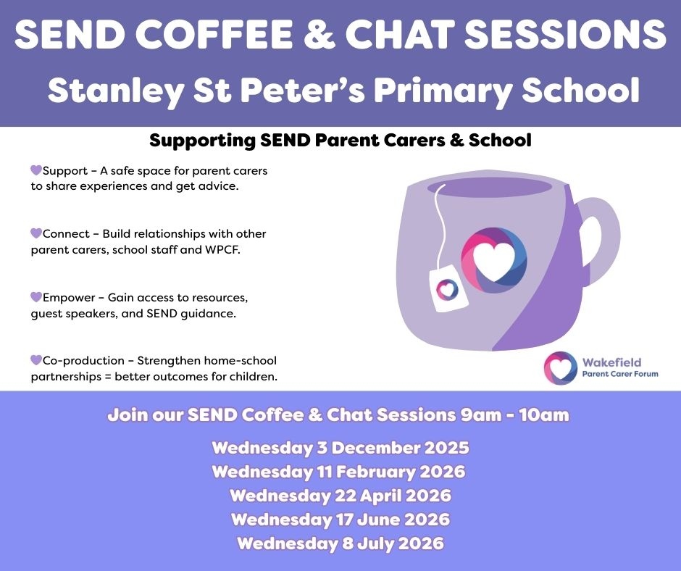

Wakefield’s Local Offer – Support for SEND Families
The Wakefield Local Offer is an online resource designed to support children and young people with special educational needs and disabilities (SEND), as well as their families. It provides a wealth of information about local services, including education, health, social care, and community support. Whether you’re looking for specialist advice, activities or guidance on accessing services, the Local Offer can help you find the right support for your child.
You can explore the Wakefield Local Offer online to see what is available in your area. If you need any help navigating the site or finding specific resources, please don’t hesitate to reach out—we’re happy to support you.
https://wakefield.mylocaloffer.org/
We recently held our first SEND Coffee & Chat session. The session focused on listening and understanding the support families feel they need, and provided a welcoming space for open discussion. Strong communication and meaningful connections between home and school are central to supporting our SEND pupils, and these sessions play an important role in strengthening that partnership. It was particularly valuable to hear from parents and carers who shared their own experiences and insights, offering reassurance and practical advice to others. We are really looking forward to our next session and would like to remind families that everyone is welcome to attend—whether you are new to SEND support or have experience to share.

