RE in EYFS: Programme of Study
The Early Years Foundation Stage (EYFS) describes the phase of a child’s education from birth to the end of the reception year at the age of five. Religious education is statutory for all pupils registered on the school roll. The statutory requirement for religious education does not extend to nursery classes in maintained schools. RE may, however, form a valuable part of the educational experience of children throughout the key stage. In the EYFS curriculum learning does not fit into boxes: play-based and child-centred approaches will encourage the learning to follow where the child’s interest and curiosity leads.

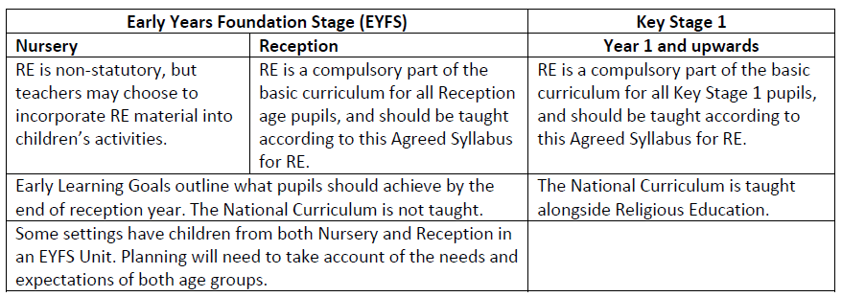
The Agreed Syllabus for RE sets out experiences and opportunities and appropriate topics for children in the Foundation Stage. The suggestions made for the EYFS RE are good learning in themselves. These also connect to some of the EYFS seven areas of learning.
Planned teaching experiences will support children’s learning and development needs identified through holistic assessment. Good Early Years teaching stems from children’s own experience and so many practitioners will find ways to draw on the wealth of religious or spiritual experiences that families may bring with them.

The EYFS statutory framework also outlines an expectation that practitioners reflect on the different ways in which children learn, the characteristics of effective learning:
• playing and exploring – children investigate and experience things, and ‘have a go’
• active learning – children concentrate and keep on trying if they encounter difficulties, and enjoy
achievements
• creating and thinking critically – children have and develop their own ideas, make links between
ideas, and develop strategies for doing things.
What do children gain from RE in this age group?
RE makes particular contributions within the prime areas of communication and language and personal, social and emotional development (PSED), as well as specific areas including understanding the world and expressive arts and design. This framework enables children to develop a positive sense of themselves, and others, and to learn how to form positive and respectful relationships. They will do this through a balance of guided, planned teaching and pursuing their own learning within an enabling environment. They will begin to understand and value the differences of individuals and groups within their own immediate community. Children will have opportunity to develop their emerging moral and cultural awareness.

RE in KS1: Programme of Study
What do pupils get out of RE at this key stage?
Pupils should develop their knowledge and understanding of religious and non-religious worldviews,
recognising their local, national and global contexts. They should use basic subject specific vocabulary. They should raise questions and begin to express their own views in response to the material they learn about and in response to questions about their ideas.

Aims:
The principal aim of RE is to engage pupils in systematic enquiry into significant human questions which religion and worldviews address, so that they can develop the understanding and skills needed to appreciate and appraise varied responses to these questions, as well as develop responses of their own.

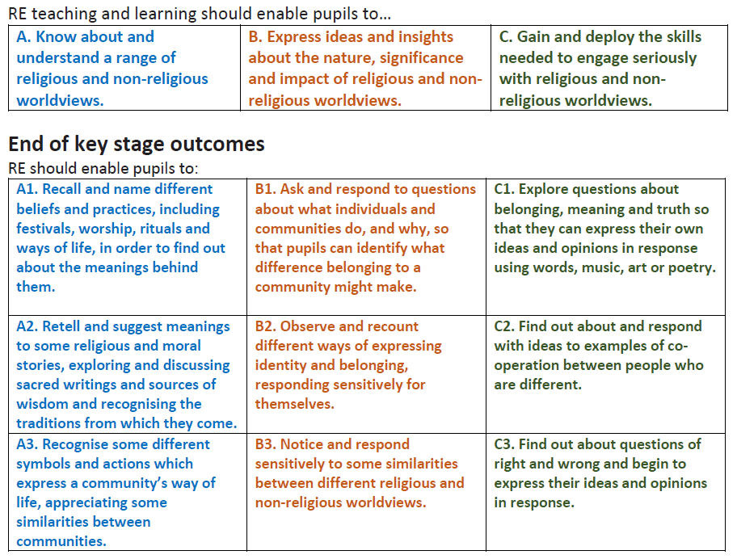

RE in KS2: Programme of Study
What do pupils get out of RE at this key stage?
Pupils should extend their knowledge and understanding of religious and non-religious worldviews,
recognising their local, national and global contexts. They should be introduced to an extended range of sources and subject-specific vocabulary. They should be encouraged to be curious and to ask increasingly challenging questions about religion, belief, values and human life. Pupils should learn to express their own ideas in response to the material they engage with, identifying relevant information, selecting examples and giving reasons to support their ideas and views.

Aims:
The principal aim of RE is to engage pupils in systematic enquiry into significant human questions which religion and worldviews address, so that they can develop the understanding and skills needed to appreciate and appraise varied responses to these questions, as well as develop responses of their own.



