 | EYFS | Year 1 | Year 2 | Year 3 |  | Year 4 | Year 5 |  | Year 6
World  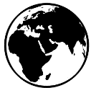 |  |  | LO: Name and locate seas surrounding the UK, as well as seas, the five oceans and seven continents around the world on a world map or globe.  Knowledge:  An ocean is a large sea. There are five oceans on our planet called the Arctic, Atlantic, Indian, Pacific and Southern Oceans. Seas include the Black, Red and Caspian Seas. The United Kingdom is an island surrounded by the Atlantic Ocean, English Channel, Irish Sea and North Sea. A continent is a large area of land. The world's seven continents are Africa, Antarctica, Asia, Australia, Europe, North America and South America.  Project: Coastline. | LO: Locate countries and major cities in Europe (including Russia) on a world map.  Knowledge:  Countries in Europe include the United Kingdom, France, Spain, Germany, Italy and Belgium. Russia is part of both Europe and Asia.  Project: Emperors and Empires |  | LO: Locate the countries and major cities of North, Central and South America on a world map, atlas or globe.  Knowledge:  The North American continent includes the countries of the USA, Canada and Mexico as well as the Central American countries of Guatemala, Honduras, Nicaragua, Costa Rica and Panama. The South American continent includes the countries of Brazil, Argentina, Chile, Colombia, Peru, Venezuela, Uruguay, Ecuador, Bolivia and Paraguay.  Project: Misty Mountain, Winding River
UK   |  | LO: Name and locate the four countries of the UK and their capital cities on a map, atlas or globe.  Knowledge:  The United Kingdom (UK) is a union of four countries: England, Northern Ireland, Scotland and Wales. A capital city is a city that is home to the government and ruler of a country. London is the capital city of England, Belfast is the capital city of Northern Ireland, Edinburgh is the capital city of Scotland and Cardiff is the capital city of Wales. The countries of the United Kingdom are made up of cities, towns and villages  Project: Bright Lights Big City |  |  |  | LO: Create a detailed study of geographical features including hills, mountains, coasts and rivers of the UK.  Knowledge:  Significant rivers of the UK include the Thames, Severn, Trent, Dee, Tyne, Ouse and Lagan. Significant mountains and mountain ranges include Ben Nevis, Snowdon, Helvellyn, Pen y Fan, the Scottish Highlands and the Pennines.  LO: Identify the topography of an area of the UK using contour lines on a map.  Knowledge:  Topography is the arrangement of the natural and artificial physical features of an area.  Project: Misty Mountain, Winding River | LO: Describe the relative location of cities, counties or geographical features in the UK in relation to other places or geographical features.  Knowledge:  Relative location is where something is found in comparison with other features.  Project: Sow Grow and Farm |  | LO: Describe patterns of human population growth and movement, economic activities, space, land use and human settlement patterns of an area of the UK or the wider world.  Knowledge:  A geographical pattern is the arrangement of objects on the Earth’s surface in relation to one another.  Project: A Child’s War
  Location and position |  | LO: Use simple directional and positional language to give directions, describe the location of features and discuss where things are in relation to each other.  Knowledge:  Positional language includes behind, next to and in front of. Directional language includes left, right, straight ahead and turn.  Project: Bright Lights Big City | LO: Use simple compass directions to describe the location of features or a route on a map.  Knowledge:  The four cardinal points on a compass are north, south, east and west. A route is a set of directions that can be used to get from one place to another.  Project: Coastline | LO: Locate significant places using latitude and longitude.  Knowledge:  Latitude is the distance north or south of the equator and longitude is the distance east or west of the Prime Meridian.  Project: Rocks Relics and Rumbles  LO: Use the eight points of a compass to locate a geographical feature or place on a map.  Knowledge:  The eight points of a compass are north, south, east, west, north-east, north-west, south-east and south-west.  Project: Rocks Relics and Rumbles | LO: Use the eight points of a compass, four and six-figure grid references, symbols and a key to locate and plot geographical places and features on a map.  Knowledge:  The four cardinal directions are north (N), east (E), south (S) and west (W), which are at 90° angles on the compass rose. The four intercardinal (or ordinal) directions are halfway between the cardinal directions: north-east (NE), south-east (SE), south-west (SW) and north-west (NW).  Project: Misty Mountain, Winding River |  |  | LO: Use compass points and grid references to interpret maps, including Ordnance Survey maps, with accuracy.  Knowledge:  Compass points can be used to describe the relationship of features to each other, or to describe the direction of travel. Accurate grid references identify the position of key physical and human features.  Project: Sow Grow and Farm | LO: Identify the position and explain the significance of latitude, longitude, equator, Northern Hemisphere, Southern Hemisphere, the Tropics of Cancer and Capricorn, the Arctic and Antarctic Circles, the Prime (or Greenwich) Meridian and time zones (including day and night).  Knowledge:  The Northern Hemisphere is the part of Earth that is to the north of the equator. The Southern Hemisphere is the part of Earth that is to the south of the equator. The Prime Meridian is the imaginary line from the North Pole to the South Pole that passes through Greenwich in England and marks 0° longitude, from which all other longitudes are measured.  Project: Frozen Kingdoms and Hola Mexico  LO: Use lines of longitude and latitude or grid references to find the position of different geographical areas and features.  Knowledge:  Invisible lines of latitude run horizontally around the Earth and show the northerly or southerly position of a geographical area. Invisible lines of longitude run vertically from the North to the South Pole and show the westerly or easterly position of a geographical area.  Project: A Child’s War and Hola Mexico
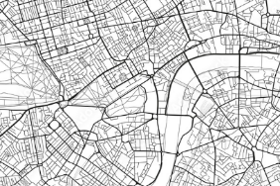  Maps |  | LO: Draw or read a simple picture map.  Knowledge:  A map is a picture or drawing of an area of land or sea that can show human and physical features. A key is used to show features on a map. A map has symbols to show where things are located.  Project: Bright Lights Big City and School Days | LO: Draw or read a range of simple maps that use symbols and a key.  Knowledge:  A map is a picture or drawing of an area of land or sea that can show human and physical features. Maps use symbols and a key. A key is the information needed to read a map and a symbol is a picture or icon used to show a geographical feature.  Project: Coastline and Magnificent Monarchs |  |  | LO: Use four or six-figure grid references and keys to describe the location of objects and places on a map.  Knowledge:  A six-figure grid reference contains six numbers and is more precise than a four-figure grid reference. The first three figures are called the easting and are found along the top and bottom of a map. The second three figures are called the northing and are found up both sides of a map. Six-figure grid references give detailed information about locations on a map.  Project: Misty Mountain Winding River |  |  | LO: Use grid references, lines of latitude and longitude, contour lines and symbols in maps and on globes to understand and record the geography of an area.  Knowledge:  A geographical area can be understood by using grid references and lines of latitude and longitude to identify position, contour lines to identify height above sea level and map symbols to identify physical and human features.  Project: Frozen Kingdoms
Compare and contrast  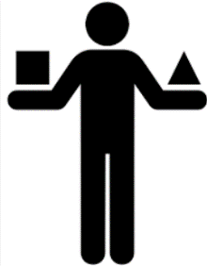 |  | LO: Identify the similarities and differences between two places.  Knowledge:  Places can be compared by size, amenities, transport, location, weather and climate.  Project: Bright Lights Big City |  | LO: Classify, compare and contrast different types of geographical feature.  Knowledge:  Geographical features created by nature are called physical features. Physical features include beaches, cliffs and mountains. Geographical features created by humans are called human features. Human features include houses, factories and train stations.  Project: Rocks Relics and Rumbles |  | LO: Describe and compare aspects of physical features.  Knowledge:  A physical feature is one that forms naturally and can change over time due to physical processes, such as erosion and weathering. Physical features include rivers, forests, hills, mountains and cliffs. An aspect of a physical feature might be the type of mountain, such as dome or volcanic, or the type of forest, such as coniferous or broad-leaved.  Project: Misty Mountain Winding River | LO: Identify and describe the similarities and differences in physical and human geography between continents.  Knowledge:  The seven continents (Africa, Antarctica, Asia, Australia, Europe, North America and South America) vary in size, shape, location, population and climate.  Project: Sow Grow and Farm |  | LO: Describe the climatic similarities and differences between two regions.  Knowledge:  Climate is the long-term pattern of weather conditions found in a particular place. Climates can be compared by looking at factors including maximum and minimum levels of precipitation and average monthly temperatures.  Project: Frozen Kingdoms
Climate and weather  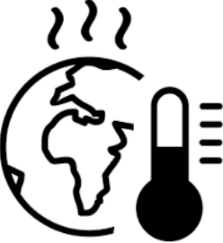 |  | LO: Identify patterns in daily and seasonal weather.  Knowledge:  There are four seasons in the UK: spring, summer, autumn and winter. Each season has typical weather patterns. Types of weather include sun, rain, wind, snow, fog, hail and sleet. In the United Kingdom, the length of the day varies depending on the season. In winter, the days are shorter. In summer, the days are longer. Symbols are used to show different types of weather.  Project: Bright Lights Big City |  |  |  |  | LO: Explain how the climate affects land use.  Knowledge:  Changes to the weather and climate (temperature, weather patterns and precipitation) can affect land use. Farmers living in different countries adapt their farming practices to suit their local climate and landscape.  Project: Sow Grow and Farm |  | LO: Evaluate the extent to which climate and extreme weather affect how people live.  Knowledge:  Climate and extreme weather can affect the size and nature of settlements, shelters and buildings, diet, lifestyle (settled or nomadic), jobs, clothing, transport and transportation links and the availability of natural resources.  Project: Frozen Kingdoms
Physical processes  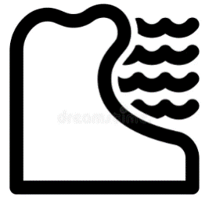  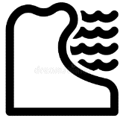 |  |  | LO: Describe, in simple terms, the effects of erosion.  Knowledge:  Erosion is a physical process that involves the weathering and movement of natural materials, such as rock, sand and soil. Erosion is caused by wind and water, including waves, floods, rivers and rainfall.  Project: Coastline | LO: Explain the physical processes that cause earthquakes and volcanic eruptions.  Knowledge:  Volcanic eruptions and earthquakes happen when two tectonic plates push into each other, pull apart from one another or slide alongside each other. The centre of an earthquake is called the epicentre.  Project: Rock Relics and Rumbles |  | LO: Use specific geographical vocabulary and diagrams to explain the water cycle.  Knowledge:  Water cannot be made. It is constantly recycled through a process called the water cycle. The four stages of the water cycle are evaporation, condensation, precipitation and collection. During the water cycle, water changes state due to heating and cooling.  Project: Misty Mountain Winding River | LO: Describe how soil fertility, drainage and climate affect agricultural land use.  Knowledge:  Soil fertility, drainage and climate influence the placement and success of agricultural land.  Project: Sow Grow and Farm
Physical features  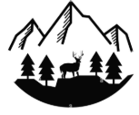 |  | LO: Use basic geographical vocabulary to identify and describe physical features, such as beach, cliff, coast, forest, hill, mountain, sea, ocean, river, soil, valley and vegetation.  Knowledge:  Physical features are naturally-created features of the Earth.  Project: Bright Lights Big City | LO: Describe the size, location and position of a physical feature, such as beach, cliff, coast, forest, hill, mountain, sea, ocean, river, soil, valley and vegetation.  Knowledge:  A physical feature is one that forms naturally, and can change over time due to weather and other forces.  Project: Coastline | lO: Describe the parts of a volcano or earthquake.  Knowledge:  A volcano is an opening in the Earth’s surface from which gas, hot magma and ash can escape. They are usually found at meeting points of the Earth's tectonic plates. When a volcano erupts, liquid magma collects in an underground magma chamber. The magma pushes through a crack called a vent and bursts out onto the Earth’s surface. Lava, hot ash and mudslides from volcanic eruptions can cause severe damage.  LO: Name and describe properties of the Earth’s four layers.  Knowledge:  The Earth is made of four different layers. The inner core is made mostly of hot, solid iron and nickel, and the outer core is made of liquid iron and nickel. The mantle is made of solid rock and molten rock called magma. The crust is a thin layer of solid rock that is broken into large pieces called tectonic plates. These pieces move very slowly across the mantle.  Project: Rock Relics and Rumbles |  | LO: Identify, describe and explain the formation of different mountain types.  Knowledge:  Mountains form over millions of years. They are made when the Earth’s tectonic plates push together or move apart. Mountains are also formed when magma underneath the Earth’s crust pushes large areas of land upwards. There are five types of mountain: fold, fault-block, volcanic, dome and plateau.  Project: Misty Mountain Winding River | LO: Identify and describe some key physical features and environmental regions of North and South America and explain how these, along with the climate zones and soil types, can affect land use.  Knowledge:  North America is broadly categorised into six major biomes: tundra, coniferous forest, grasslands (prairie), deciduous forest, desert and tropical rainforest. South America has a vast variety of biomes, including desert, alpine, rainforest and grasslands.  Project: Sow Grow and Farm |  | LO: Compare and describe physical features of polar landscapes.  Knowledge:  The Arctic is a sea of ice surrounded by land and located at the highest latitudes of the Northern Hemisphere. It extends over the countries that border the Arctic Ocean, including Canada, the USA, Denmark, Russia, Norway and Iceland. Antarctica is a continent located in the Southern Hemisphere. Antarctica does not belong to any country. Physical features typical of the Arctic and Antarctic regions include glaciers, icebergs, ice caps, ice sheets, ice shelves and sea ice.  Project: Frozen Kingdoms
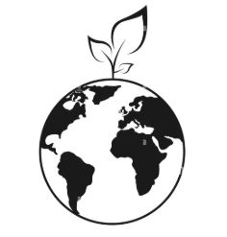  Environment |  | LO: Describe how pollution and litter affect the local environment and school grounds.  Knowledge:  Litter and pollution have a harmful effect on the areas where we live, work and play.  Project: School Days | LO: Describe ways to improve the local environment.  Knowledge:  The local environment can be improved by picking up litter, planting flowers and improving amenities.  DISCRETE |  |  | LO: Describe altitudinal zonation on mountains.  Knowledge:  Altitudinal zonation describes the different climates and types of wildlife at different altitudes on mountains. Examples include forests that grow at low altitudes and support a wide variety of plants and animals, tundra that is found at higher altitudes and supports plants and animals that are adapted to harsher environments, and the summits of mountains, which are usually covered in ice and snow and don't support any life.  Project: Misty Mountain Winding River | LO: Name and locate the world’s biomes, climate zones and vegetation belts and explain their common characteristics.  Knowledge:  The Earth has five climate zones: desert, equatorial, polar, temperate and tropical. A biome is a large ecological area on the Earth's surface, such as desert, forest, grassland, tundra and aquatic. Biomes are often defined by a range of factors, such as temperature, climate, relief, geology, soils and vegetation.  Project: Sow Grow and Farm |  | LO: Explain how climate change affects climate zones and biomes across the world.  Knowledge:  Climate change is the long-term change in expected patterns of weather that contributes to the melting of polar ice caps, rising sea levels and extreme weather. Climate change is caused by global warming. Human activity, such as burning fossil fuels, deforestation, habitat destruction, overpopulation and rearing livestock, all contribute to global warming.  Project: Frozen Kingdoms
Human features and landmarks  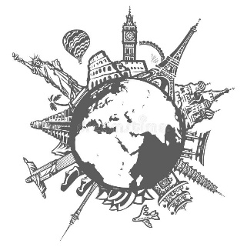 |  | LO: Name and describe the purpose of human features and landmarks.  Knowledge:  Human features are man-made and include factories, farms, houses, offices, ports, harbours and shops. Landmarks and monuments are features of a landscape, city or town that are easily seen and recognised from a distance. They also help someone to establish and describe a location.  Project: Bright Lights Big City | LO: Use geographical vocabulary to describe how and why people use a range of human features.  Knowledge:  Human features are man-made and include castles, towers, schools, hospitals, bridges, shops, tunnels, monuments, airports and roads. People use human features in different ways. For example, an airport can be used for work or leisure and a harbour can be used for industry or travel.  Project: Movers and Shakers and Coastline | LO: Describe the type and purpose of different buildings, monuments, services and land, and identify reasons for their location.  Knowledge:  Services include banks, post offices, hospitals, public transport and garages. Land use types include leisure, housing, industry, transport and agriculture.  Project: Through the Ages |  | LO: Describe a range of human features and their location and explain how they are interconnected.  Knowledge:  Human features can be interconnected by function, type and transport links.  Project: Misty Mountain Winding River | LO: Describe and explain the location and purpose of transport networks across the UK and other parts of the world.  Knowledge:  Transport networks can be tangible, such as rails, roads or canals, or intangible, such as air and sea corridors. These networks link places together and allow for the movement of people and goods. Transport networks are usually built where there is a high demand for the movement of people or goods. They run between places where journeys start or finish, such as airports, bus stations, ferry terminals or railway stations.  Project: Sow Grow and Farm |  | LO: Explain how humans function in the place they live.  Knowledge:  The distribution of and access to natural resources, cultural influences and economic activity are significant factors in community life in a settlement.  Project: Frozen Kingdoms and Hola Mexico
Settlements and land use  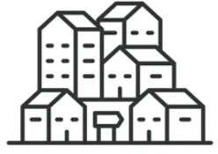  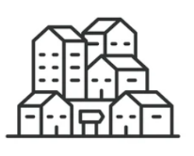 |  | LO: Identify the characteristics of a settlement.  Knowledge:  A settlement is a place where people live and work and can be big or small, depending on how many people live there. Towns and cities are urban settlements. Features of towns and cities include homes, shops, roads and offices.  Project: Bright Lights Big City, Childhood and School Days | LO: Describe the size, location and function of a local industry.  Knowledge:  Industries are businesses that make things, sell things and help people live their everyday lives. Land can be used for recreational, transport, agricultural, residential and commercial purposes, or a mixture of these.  Project: Coastline |  |  | LO: Explain ways that settlements, land use or water systems are used in different parts of the world.  Knowledge:  Land uses include agricultural, recreational, housing and industry. Water systems are used for transport, industry, leisure and power.  Project: Misty Mountain Winding River | LO: Describe in detail the different types of agricultural land use in the UK.  Knowledge:  Agricultural land use in the UK can be divided into three main types, arable (growing crops), pastoral (livestock) and mixed (arable and pastoral). An allotment is a small piece of land used to grow fruit, vegetables and flowers. A wide variety of crops are farmed in the UK, such as wheat, barley, oats, potatoes, other vegetables, fruits and oilseed rape. A wide variety of livestock are reared on farms in the UK, such as sheep, dairy cattle, beef cattle, poultry and pigs.  Project: Sow Grow and Farm |  | LO: Describe the distribution of natural resources in an area or country.  Knowledge:  Natural resources include food, minerals (aluminium, sandstone and oil) energy sources (water, coal and gas) and water.  Project: Frozen Kingdoms
Geographical resources  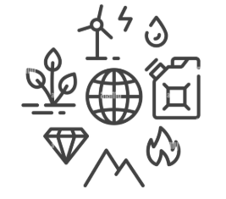 |  | LO: Identify features and landmarks on an aerial photograph or plan perspective.  Knowledge:  An aerial photograph or plan perspective shows an area of land from above.  Project: Bright Lights Big City | LO: Study aerial photographs to describe the features and characteristics of an area of land.  Knowledge: An aerial photograph can be vertical (an image taken directly from above) or oblique (an image taken from above and to the side).  Project: Coastline | LO: Analyse maps, atlases and globes, including digital mapping, to locate countries and describe features studied.  Knowledge: Maps, globes and digital mapping tools can help to locate and describe significant geographical features.  Project: Rocks Relics and Rumbles, Through the Ages and Emperors and Empires |  | LO: Study and draw conclusions about places and geographical features using a range of geographical resources, including maps, atlases, globes and digital mapping.  Knowledge:  An atlas is a collection of maps and information that shows geographical features, topography, boundaries, climatic, social and economic statistics of an area.  Project: Misty Mountain Winding River |  |  | LO: Use satellite imaging and maps of different scales to find out geographical information about a place.  Knowledge: Satellite images are photographs of Earth taken by imaging satellites.  Project: Frozen Kingdoms and Hola Mexico
Data Analysis  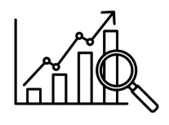 |  | LO: Collect simple data during fieldwork activities.  Knowledge:  Data is information that can be collected and used to answer a geographical question.  Project: Bright Lights Big City | LO: Collect and organise simple data in charts and tables from primary sources (fieldwork and observation) and secondary sources (maps and books).  Knowledge:  Data can be recorded in different ways, including tables, charts and pictograms.  Project: Coastline |  |  | LO: Collect and analyse primary and secondary data, identifying and analysing patterns and suggesting reasons for them.  Knowledge:  Secondary data includes information gathered by geographical reports, surveys, maps, research, books and the internet.  Project: Misty Mountain Winding River | LO: Summarise geographical data to draw conclusions.  Knowledge:  Geographical data, such as demographics or economic statistics, can be used as evidence to support conclusions.  Project: Sow Grow and Farm
Fieldwork  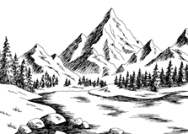 |  | LO: Carry out fieldwork tasks to identify characteristics of the school grounds or locality.  Knowledge:  Fieldwork includes going out in the environment to look, ask questions, take photographs, take measurements and collect samples.  Project: Bright Lights Big City and School Days | LO: Ask and answer simple geographical questions through observation or simple data collection during fieldwork activities.  Knowledge:  Fieldwork can help to answer questions about the local environment and can include observing or measuring, identifying or classifying and recording.  Project: Coastline | LO: Gather evidence to answer a geographical question or enquiry.  Knowledge:  The term geographical evidence relates to facts, information and numerical data.  Project: Rocks Relics and Rumbles |  |  | LO: Construct or carry out a geographical enquiry by gathering and analysing a range of sources  Knowledge:  A geographical enquiry can help us to understand the physical geography (rivers, coasts, weather and rocks) or human geography (population changes, migration, land use, changes to inner city, urbanisation, developments and tourism) of an area and the impacts on the surrounding environment.  Project: Sow Grow and Farm |  | LO: Ask and answer geographical questions and hypotheses using a range of fieldwork and research techniques.  Knowledge:  Representing, analysing, concluding, communicating, reflecting and responding are helpful strategies to answer geographical questions.  Project: Frozen Kingdoms
Natural and man made materials  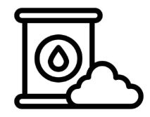 |  |  |  | LO: Name and describe the types, appearance and properties of rocks.  Knowledge:  There are three main types of rock found in the Earth's crust. They are sedimentary, igneous and metamorphic. Sedimentary rocks are made from sediment that settles in water and becomes squashed over a long time to form rock. They are often soft, permeable, have layers and may contain fossils. Igneous rocks are made from cooled magma or lava. They are usually hard, shiny and contain visible crystals. Metamorphic rocks are formed when existing rocks are heated by the magma under the Earth’s crust or squashed by the movement of the Earth’s tectonic plates. They are usually very hard and often shiny.  Project: Rocks Relics and Rumbles and Through the Ages |  | LO: Describe and explain the transportation of materials by rivers.  Knowledge:  Rivers transport materials in four ways. Solution is when minerals are dissolved and carried in the water. Suspension is when fine, light material is carried. Saltation is when small pebbles and stones are carried along the riverbed. Traction is when large boulders and rocks are rolled along the riverbed.  Project: Misty Mountain Winding River | LO: Explain how the topography and soil type affect the location of different agricultural regions.  Knowledge:  The topography of an area intended for agricultural purposes is an important consideration. In particular, the topographical slope or gradient plays a large part in controlling hydrology (water) and potential soil erosion.  Project: Sow Grow and Farm |  | LO: Explain how the presence of ice makes the polar oceans different to other oceans on Earth.  Knowledge:  The polar oceans are significantly colder than other world oceans. This influences the presence of sea ice, glaciers and icebergs.  Project: Frozen Kingdoms
Significant Places  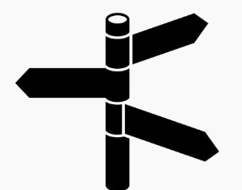 |  | LO: Name important buildings and places and explain their importance.  Knowledge:  A place can be important because of its location, buildings, landscape, community, culture and history. Important buildings can include schools, places of worship and buildings that provide a service to the community, such as shops and libraries. Some buildings are important because they tell us something about the past.  Project: Bright Lights Big City | LO: Name, locate and explain the significance of a place.  Knowledge:  A significant place is a location that is important to a community or society. Places can also be significant because of religious or historic events that may have happened in the past near the location. Significant places can also include monuments, such as the Eiffel Tower, or natural landscapes, such as the Great Barrier Reef.  Project: Coastline, Movers and Shakers and Magnificent Monarchs | LO: Name and locate significant volcanoes and plate boundaries and explain why they are important.  Knowledge:  Significant volcanoes include Mount Vesuvius in Italy, Laki in Iceland and Krakatoa in Indonesia. Significant earthquake-prone areas include the San Andreas Fault in North America and the Ring of Fire, which runs around the edge of the Pacific Ocean and is where many plate boundaries in the Earth's crust converge. Over three-quarters of the world’s earthquakes and volcanic eruptions happen along the Ring of Fire.  Project: Rocks Relics and Rumbles |  | LO: Name, locate and explain the importance of significant mountains or rivers.  Knowledge:  Significant mountain ranges include the Himalayas, Urals, Andes, Alps, Atlas, Pyrenees, Apennines, Balkans and Sierra Nevada. Significant rivers include the Mississippi, Nile, Thames, Amazon, Volga, Zambezi, Mekong, Ganges, Danube and Yangtze.  Project: Misty Mountain Winding River | LO: Identify some of the problems of farming in a developing country and report on ways in which these can be supported.  Knowledge:  Farming challenges for developing countries include poor soil, disease, drought and lack of markets. Education, fair trade and technology are ways in which these challenges can be reduced.  Project: Sow Grow and Farm |  | LO: Name, locate and explain the distribution of significant industrial regions around the world.  Knowledge:  North America, Europe and East Asia are the main industrial regions of the world due to a range of factors (access to raw materials, transportation, fresh water, power and labour supply).  Project: Frozen Kingdoms
Geographical Change  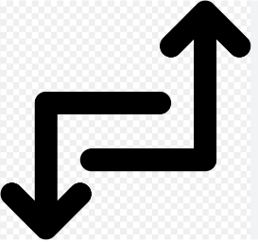  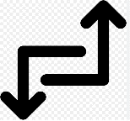 |  | LO: Describe how a place or geographical feature has changed over time.  Knowledge:  Geographical features can change over time.  Project: School Days and Childhood | LO: Describe how an environment has or might change over time.  Knowledge:  An environment or place can change over time due to a geographical process, such as erosion, or human activity, such as housebuilding.  Project: Coastline | LO: Describe how a significant geographical activity has changed a landscape in the short or long term.  Knowledge:  Significant geographical activity includes earthquakes and volcanic eruptions. These are known as natural disasters because they are created by nature, affect many people and cause widespread damage.  LO: Describe the activity of plate tectonics and how this has changed the Earth’s surface over time (continental drift).  Knowledge:  The crust of the Earth is divided into tectonic plates that move. The place where plates meet is called a plate boundary. Plates can push into each other, pull apart or slide against each other. These movements can create mountains, volcanoes and earthquakes.  Project: Rocks Relics and Rumbles |  | LO: Explain how the physical processes of a river, sea or ocean have changed a landscape over time.  Knowledge:  Rivers, seas and oceans can transform a landscape through erosion, deposition and transportation.  Project: Misty Mountain Winding River |  |  | LO: Present a detailed account of how an industry, including tourism, has changed a place or landscape over time.  Knowledge:  Tourism is an industry that involves people travelling for recreation and leisure. It has had an environmental, social and economic impact on many regions and countries.  Project: Frozen Kingdoms
Subject Leader Notes:

