Pupil premium strategy statement

This statement details our school’s use of pupil premium funding to help improve the attainment of our disadvantaged pupils.

It outlines our pupil premium strategy, how we intend to spend the funding in this academic year and the effect that last year’s spending of pupil premium had within our school.

School overview
Detail | Data
School name | Stanley St Peter’s CE Primary School
Number of pupils in school | 286
Proportion (%) of pupil premium eligible pupils | 27%
Academic year/years that our current pupil premium strategy plan covers (3 year plans are recommended) | 2024 - 2027
Date this statement was published | 30/12/2025
Date on which it will be reviewed | 30/12/2026
Statement authorised by | Michelle Wiggins
Pupil premium lead | Michelle Wiggins
Governor / Trustee lead | Catrin Chan
Funding overview
Detail | Amount
Pupil premium funding allocation this academic year | £136,185
Recovery premium funding allocation this academic year | £0
Pupil premium funding carried forward from previous years (enter £0 if not applicable) | £0
Total budget for this academic year  If your school is an academy in a trust that pools this funding, state the amount available to your school this academic year | £136,185

Part A: Pupil premium strategy plan

Statement of intent
All our staff and governors accept responsibility for all pupils and are committed to meeting their pastoral, social and academic needs within a caring Christian environment. The targeted and strategic use of pupil premium funding will support us in achieving our vision of ‘Unlock Potential, Celebrate Success’ for every single one of our pupils.
Principles
We seek to ensure that teaching and learning opportunities meet the needs of all of the pupils;
We seek to ensure that appropriate provision is made for pupils who belong to vulnerable groups, this includes ensuring that the needs of socially disadvantaged pupils are adequately assessed and addressed;
In making provision for pupil premium pupils, we recognise that not all pupils who receive free school meals will be socially disadvantaged;
We also recognise that not all pupils who are socially disadvantaged are registered or qualify for free school meals. We reserve the right to allocate the Pupil Premium funding to support any pupil or groups of pupils the school has legitimately identified as being in need of intervention and support;
Pupil premium funding will be allocated following a needs analysis, which will identify priority classes, groups or individuals.

Challenges

This details the key challenges to achievement that we have identified among our disadvantaged pupils.
Challenge number | Detail of challenge
1 | Need to strengthen spoken language, vocabulary acquisition, and reading fluency across all year groups to support comprehension and writing.
2 | Limited cultural capital and experiential learning opportunities impacting pupils’ ability to make connections in reading, writing, and problem-solving.
3 | Some disadvantaged pupils’ parents lack the confidence, knowledge, or understanding to effectively support their child’s learning and may not fully recognise the long-term benefits of a good education.
4 | Persistent attendance challenges and social-emotional needs affecting engagement and progress, requiring targeted pastoral support and attendance strategies.

Intended outcomes
This explains the outcomes we are aiming for by the end of our current strategy plan, and how we will measure whether they have been achieved.
Intended outcome | Success criteria
Children have increased spoken language skills and an increase in spoken vocabulary this will be evident in EYFS assessments.  In EYFS all children make good progress from there CLLD baseline assessments.  In Year 1 all children read at age related expectations measured by teacher assessment and phonics groups.  By the end of KS2 the PP gap in reading improves. | Teacher assessment in EYFS evidence all PP children make good levels of progress in CLLD.  Y1 children passing the phonics screening check is in line with national @ 92%  In other year groups, all children make good progress with reading measured by teacher assessment and Star Reading scores.  By the end of the KS2 the PP gap continues to improve and align with National levels.
Children’s speech, reading comprehension, creative writing and problem solving skills are improved because children have experiences to draw on and link to in their learning. Lessons are sequenced to build on children’s prior learning. Educational visits and practical learning opportunities provide pupils with experiential learning proven by EEF research to improve standards. This will be measured through monitoring of work outcomes, lesson observations, pupil voice, learning walks and assessments against the National Curriculum. | We diminish the difference in EYFS, KS1 and KS2 attainment between disadvantaged and non-disadvantaged pupils.
Any retained reflexes that children have are tackled and gross and fine motor skills improve leading to an improvement in children’s writing outcomes and visual tracking for reading skills are improved which lead to better outcomes in reading. | We diminish the difference in EYFS, KS1 and KS2 attainment between disadvantaged and non-disadvantaged pupils.  Physical literacy assessments evidence progress made.
All outcomes are in line with or above National.  A strong Reading culture will be embedded across school.  Writing - author visits and experiential learning opportunities support creative writing stimuli, artefacts and educational visits ensure hands on experiences that will feed into extended writing opportunities.  Maths Mastery and SDI approach ensures pupils are secure with fluency before moving on to reasoning and problem solving questions in every lesson.  Times table rock stars supports the teaching of multiplication and times tables.  Arithmetic has a high profile in school. | Reading ambassadors are appointed in every year group.  Reading comprehension has a high profile in school. Our GR characters provide a structure to the teaching of comprehension.  Reading is promoted around school.  Marking policy ensure high expectations of all staff and consistency of approach.  Teaching and learning is monitored through the schools monitoring cycle and evidences that disadvantaged children are making progress in line with their peers.
Attendance and persistent absence in line with national as a result of the implementation of attendance incentives such as class jigsaws, Stan-o-poly game, vouchers, certificates and medals.  Work closely with EWO.  Regular monitoring of data and interventions swiftly undertaken (including the issue of penalty notices) when required as per our attendance policy. | There is clear tracking of attendance and a rapid response approach for non-attendance. Consistent and clear communication with all parents is in place. Fast track meetings for persistent absentees and monitoring period of improvement are in place when attendance drops to 92%. If escalation is needed then EWO procedures are followed. Our attendance policy is followed robustly.
Children can manage their behaviour with increased responsibility. Children can regulate their emotions with increased control. Children can understand and accept consequences with fewer exhibits of unacceptable behaviours. Exclusions are reduced in frequency and number. | Pastoral support in place to effectively manage all pupils’ needs.  Learning mentor timetable support learning needs and social and emotional development. All interventions are monitored and reviewed. Boxall assessments are in place for individual children

Activity in this academic year
This details how we intend to spend our pupil premium (and recovery premium funding) this academic year to address the challenges listed above.

Teaching (for example, CPD, recruitment and retention)
Budgeted cost: £ 53,300
Activity | Evidence that supports this approach | Challenge number(s) addressed
Ensure that all staff receive high quality ongoing CPD plus coaching sessions for the effective delivery of the Read Write Inc. synthetic phonics programme and implement it to a consistently high standard  Resources and subscription to online learning package purchased to assist parental engagement with phonics at home. | Reading by Six – in 2010 the UK government studied the twelve highest performing schools across the UK, seven of them taught Read Write Inc.  EEF conducted a study into the effectiveness of RWI and found that children made an additional 1 months progress but that children eligible for FSM made an additional 3 months progess.  Good/outstanding teaching leads to good/outstanding outcomes. Ofsted 2013. | 1, 3, 4
Ensure that all staff receive high quality ongoing CPD and support to continue to embed our whole class guided reading approach from Year 2 – 6 through our reading content domain characters using consistent strategies and language.  Introduction of our new vocabulary and fluency skills lessons and training for all staff on this. | EEF guidance documents ‘Improving Literacy in KS1’ and ‘Improving Literacy in KS2’ published 27/10/21.  Reading comprehension strategies add +6 months of learning. Evidenced by Education Endowment Fund research – Teaching and learning toolkit.  DfE Reading Framework 2023. | 1, 3, 4
Ensure that all staff across the school continue to embed the Power Maths scheme for mastery mathematics teaching (including the introduction of the scheme into EYFS) to a consistently high standard and implement same-day intervention sessions.  Textbooks and subscription to online resources purchased. | Mastery Learning adds +5 months. Evidenced by Education Endowment Fund research – Teaching and learning toolkit.  Power Maths scheme recommended by DfE. | 3, 4
Ensure that staff are trained and supported to implement the English Framework (which includes spelling strategies and handwriting scheme) to take into account the mixed-aged classes in KS2 and can accurately moderate work.  Invest in class novels linked to topic to inspire writing.  Vocabulary-rich learning environments.  Embed Grammarsaurus and provide CPD for staff (a scheme to rapidly improve writing, grammar and punctuation). | EEF guidance documents ‘Improving Literacy in KS1’ and ‘Improving Literacy in KS2’ published 27/10/21. | 1, 3, 4
Improved personal development - Children have experiences to draw on and link to in their learning. Lessons are sequenced to build on children’s prior learning. | Educational visits and practical learning opportunities provide pupils with experiential learning proven by EEF research to improve standards. | 1, 2, 4

Targeted academic support (for example, tutoring, one-to-one support structured interventions)
Budgeted cost: £ 49,390
Activity | Evidence that supports this approach | Challenge number(s) addressed
Implement one to one phonics tuition for children who are underachieving for their age and stage.  Phonics intervention groups for children in year groups other than Y1 who did not pass the phonics screening in Year 1.  Parents well informed of phonics teaching strategies in order to support their child at home effectively and resources provided to enable this (including home learning package subscription). | One to one tuition adds average +6 months in primary schools.  Both evidenced by Education Endowment Fund research – Teaching and learning toolkit.  DfE Research - English Hub Involvement | 1, 3, 4
Additional reading teacher employed in order to allow smaller groups and release reading leader to coach staff teaching lowest 20% of children. | Smaller class sizes add +2 months of learning. Evidenced by Education Endowment Fund research – Teaching and learning toolkit.  Good/outstanding teaching leads to good/outstanding outcomes. Ofsted 2013. | 1, 3, 4
Implement small group reading interventions for lowest 20% of readers.  Opportunities provided for reading one to one more often with an adult for lowest 20% readers.  Embed use of Accelerated Reader across Years 2 - 6 to increase reading for pleasure. | Small group tuition adds +4 months of learning.  One to one tuition adds average +6 months in primary schools.  Both evidenced by Education Endowment Fund research – Teaching and learning toolkit. | 1, 3, 4
Speech and Language therapist employed one day per fortnight to address issues with speech, communication and language. | EEF Early Years Toolkit. Communication & Language Approaches. | 1
Physical Literacy Consultant employed one day per week to address issues of retained reflexes and improve children’s fine and gross motor skills and visual tracking skills for reading. | Persistence of primitive reflexes and associated motor problems in healthy preschool children (14/1/08)  Smart Moves: Why not all learning is in your head  Dr Carla Hannaford | 1, 2, 4
Embed daily ‘morning work’ basic arithmetic skills intervention groups.  Implement small group maths interventions for children below age-related expectations.  Offer same day intervention groups and further interventions for children who have accessed SDI but are still struggling with the maths concept being taught.  Use of TT Rockstars | Small group tuition adds +4 months of learning. Evidenced by Education Endowment Fund research – Teaching and learning toolkit.  Case study by The Shine Trust:  An estimated 370,000 disadvantaged children are benefitting from Times Tables Rock Stars. The most recent speed data on more than 327,000 children shows that on average, students are 38% faster at answering times tables questions after using Times Tables Rock Stars than when they started using it. | 1, 3, 4

Wider strategies (for example, related to attendance, behaviour, wellbeing)
Budgeted cost: £ 33,495
Activity | Evidence that supports this approach | Challenge number(s) addressed
Attendance and persistent absence in line with national as a result of the implementation of attendance incentives such as class jigsaws, Stan-o-poly game, vouchers, certificates and medals.  Employment of Attendance Officer 12.5 hours per week.  Attendance Officer to work closely with EWO.  Implementation of the recommendations within the Wakefield Attendance Strategy.  Regular monitoring of data and interventions swiftly undertaken (including sending text messages to parents, the issue of penalty notices and home visits) when required as per our attendance policy. | Working Together to Improve School Attendance DfE 19/8/24  Wakefield School Attendance Strategy 2023-2026  Texting parents (+1 month) Parental Engagement (+4 months). Evidenced by Education Endowment Fund research – Teaching and learning toolkit | 4
Pastoral support in place to effectively manage all pupils’ needs.  Learning mentor timetable support learning needs and social and emotional development. All interventions are monitored and reviewed. Boxall assessments are in place for individual children. | The average impact of behaviour interventions is four additional months’ progress over the course of a year. Evidenced by Education Endowment Fund research – Teaching and learning toolkit | 4

Total budgeted cost: £ 128,895

Part B: Review of outcomes in the previous academic year

Pupil premium strategy outcomes
This details the impact that our pupil premium activity had on pupils in the 2024 to 2025 academic year.
Our end of KS2 outcomes for 2025 were strong across all areas. We exceeded national averages at the expected standard or higher in reading (+19%), writing (+15%), maths (+17%) and in the combined reading, writing and maths measure (RWM) (+25%).
At greater depth, we were also above national figures in reading (+28%), writing (+4%), maths (+21%) and RWM combined (+4%).
Outcomes for disadvantaged pupils were particularly positive.
- 69% achieved the expected standard or higher in RWM combined (+25% above the national average).
- 77% reached the expected standard or higher in reading (+14% above national).
- 69% met the expected standard or higher in writing (+10% above national).
- 69% achieved the expected standard or higher in maths (+10% above national).
Performance at greater depth also showed encouraging results for disadvantaged pupils:
- 8% achieved greater depth in RWM combined (+5% above 2024 national averages).
- 38% achieved greater depth in reading (+20% above 2024 national).
- 15% reached greater depth in writing (+9% above 2024 national).
- 23% achieved greater depth in maths (+10% above 2024 national).
(National averages for disadvantaged pupils in 2025 are not yet available.)
The attainment gap between disadvantaged pupils and their peers has narrowed in RWM combined and in writing. Although the gap has widened this year in reading and maths at the expected standard, our disadvantaged pupils continue to perform well above national averages in both subjects. At greater depth, the gap has closed further across all areas.
In Phonics Screening and Good Level of Development, disadvantaged children outperformed their peers, and the gap is also narrowing in our Multiplication Tables Check results.
Overall, these outcomes demonstrate that our pupil premium strategy is having a positive impact, while also highlighting areas where further work is needed to continue closing the remaining gaps.
Stanley St. Peter’s Disadvantaged Achievement 2024-25
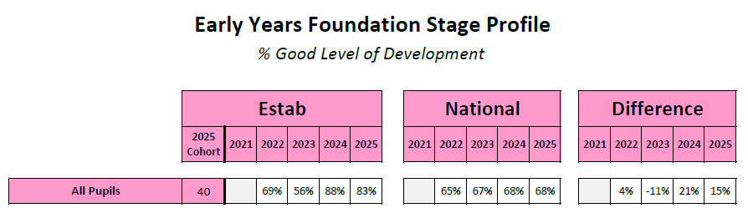
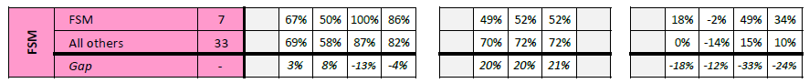
The attainment of FSM pupils in Reception decreased last year at a Good Level of Development by 14% in 2025 but is 34% above the national figure for FSM in 2024 at 83%. FSM pupils outperformed All others.
RAG rating
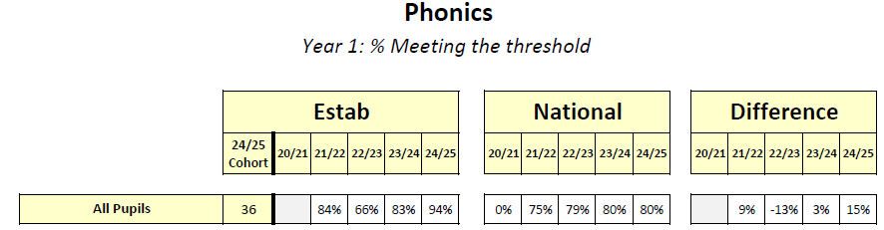
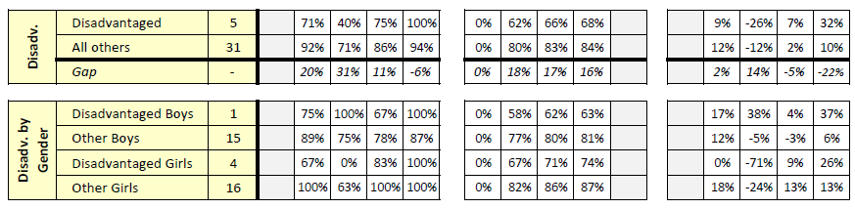
Last year, the percentage of Disadvantaged pupils in Year 1 meeting the phonics threshold increased by 25% to 100%. This is 32% above the national Disadvantaged figure from 2024. Disadvantaged pupils outperformed All others.
RAG rating

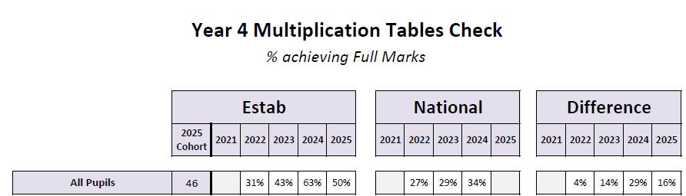
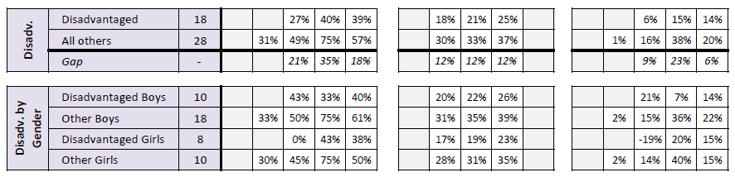
The percentage of Disadvantaged pupils achieving full marks in the MTC decreased by 1% in 2025. However, the figure is 14% above 2024 national average for Disadvantaged pupils. The gap between Disadvantaged and All others in school reduced by 17% last year.
RAG rating

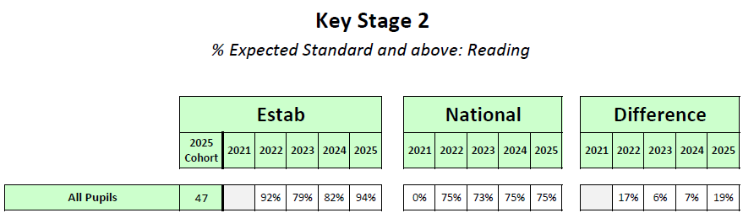
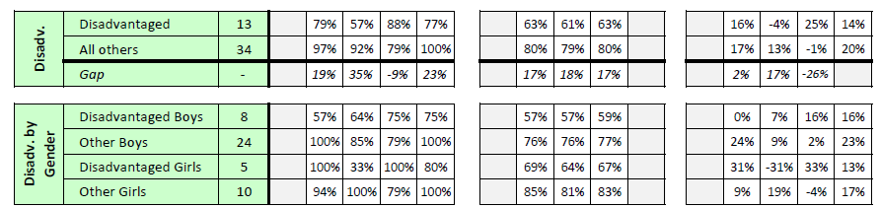
The percentage of Disadvantaged pupils attaining the expected standard at the end of KS2 decreased by 11% in reading to 77%. However, the figure is 14% above the 2024 national average for Disadvantaged in reading.
RAG rating

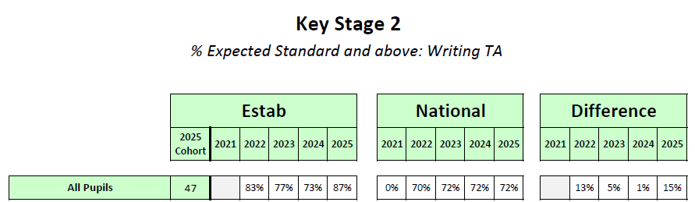
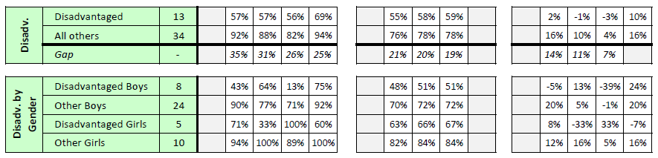
The percentage of Disadvantaged pupils attaining the expected standard at the end of KS2 increased by 13% in writing. Moreover, the figure is 10% above the national average for Disadvantaged in writing.
RAG rating

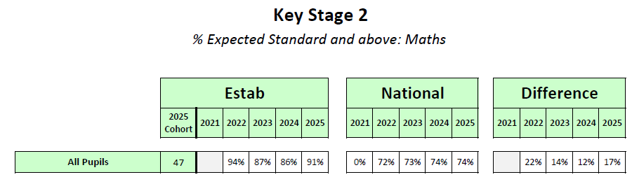
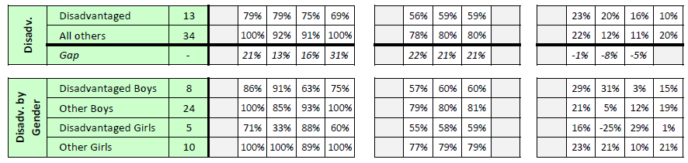
The percentage of Disadvantaged pupils attaining the expected standard at the end of KS2 decreased by 6% in maths. However, the figure is 10% above the 2024 national average for Disadvantaged in maths.
RAG rating

Externally provided programmes
Please include the names of any non-DfE programmes that you purchased in the previous academic year. This will help the Department for Education identify which ones are popular in England
Programme | Provider
Accelerated Reader | Renaissance Learning
TT Rockstars | Maths Circle
Read Write Inc | Ruth Miskin
Power Maths | Pearson
My Happy Mind | My Happy Mind

