Stanley St Peter’s CE Primary School History - Significant individuals to be studied during Cycle B

 | Autumn Term | Spring Term | Summer Term
EYFS | Community firefighters, policemen, Doctors  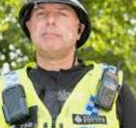  Guy Fawkes  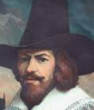  A member of the failed gun powder plot. Remembered at Bonfire night. | Nelson Mandela  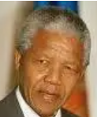  South African anti-apartheid activist and politician who served as the first president of South Africa from 1994 to 1999.  Jesus.  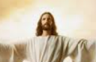  Christians believe him to be the son of God | King Charles III  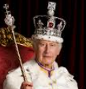  Present king of England  David Attenborough  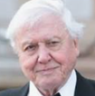  English broadcaster and natural historian.
Year 1/ 2 | Queen Elizabeth II  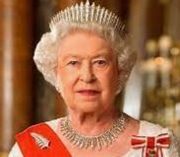  Queen of the United Kingdom from February 6, 1952, the longest-reigning monarch in British history | Samuel Pepys  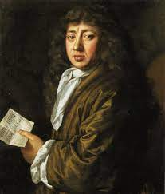  Administrator of the navy of England and Member of Parliament who is most famous for the diary he kept detailing the Great fire of London | Samuel Wilderspin  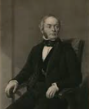  English educator pioneering work in infant schools  (died in Wakefield)
Year 3/4 | King Athelstan  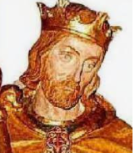  King of the Anglo-Saxons from 924 to 927 and King of the English from 927 to 939 | Mary Anning  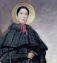  English fossil collector, dealer, and palaeontologist | Tutankhamun  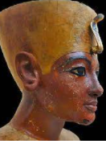  An ancient Egyptian pharaoh who was the last of his royal family to rule during the end of the 18th Dynasty during the New Kingdom of Egyptian history.
Year 5/6 | Fu Hao  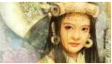  One of the many wives of King Wu Ding of the Shang dynasty and also served as a military general and high priestess | Roger Nicholson    Farmer at Cannon Hall farm, Barnsley | Pythagoras  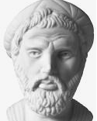  An ancient Ionian Greek philosopher and the eponymous founder of Pythagoreanism.
Local significant individual

