Stanley St Peter’s CE Primary School History - Significant individuals to be studied during Cycle A

 | Autumn Term | Spring Term | Summer Term
EYFS | Community firefighters, policemen, Doctors  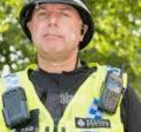  Guy Fawkes  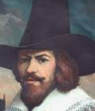  A member of the failed gun powder plot. Remembered at Bonfire night. | Nelson Mandela  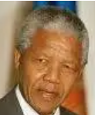  South African anti-apartheid activist and politician who served as the first president of South Africa from 1994 to 1999.  Jesus.  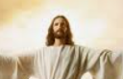  Christians believe him to be the son of God | King Charles III  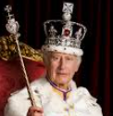  Present king of England  David Attenborough  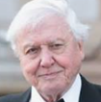  English broadcaster and natural historian.
Year 1/2 | Charles Waterton  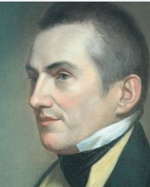  Naturalist and Explorer  Local to Wakefield  A skilled taxidermist, he preserved many of the animals he encountered on his expeditions. | Queen Victoria  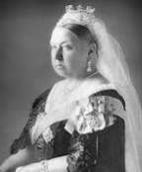  Former Queen of England  Reigned for 63 years  Victoria Era | Captain James Cook  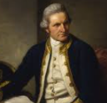  British explorer, navigator, cartographer, and captain in the British Royal Navy, famous for his three voyages in the Pacific and Australia
Year 3/4 | Amesbury Archer  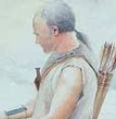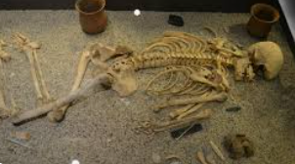  Early Bronze Age man whose grave was discovered during excavations in Amesbury near Stonehenge. | Alan Hinkes  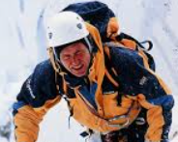  Local mountaineer who was first British person to climb all 14 Himalayan mountains above 8,000ft | Boudica  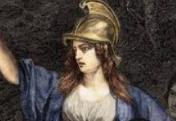  Queen of the British Celtic Iceni tribe who led an uprising against the conquering forces of the Roman Empire in AD 60 or 61
Year 5/6 | Claudia Jones  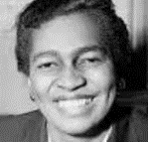  Claudia Vera Jones was a Trinidad and Tobago-born journalist and activist. | Ernest Shackleton  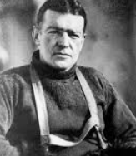  Explorer  Antarctic explorer who led three British expeditions to the Antarctic. | Adolf Hitler  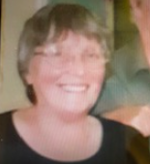  Local lady who joined Women’s land army in World War 2  Also worked at Stanley St Peters school
Local significant individual

