 |  | Autumn |  |  | Spring |  | Summer
Curriculum Stimuli | Project Title | Maafa  (Companion Project: Trailblazers, Barrier Breakers) |  |  | Frozen Kingdoms  (Companion Project: Inuit) |  | Britain at War  (Companion Project: Bees, Beetles & Butterflies)
Curriculum Stimuli | Book | 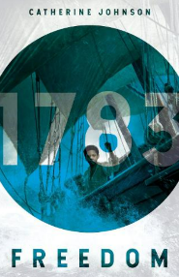  Freedom by Catherine Johnson |  |  | 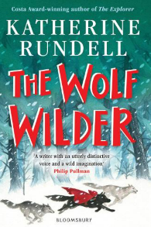  The Wolf Wilder by Katherine Rundell |  | 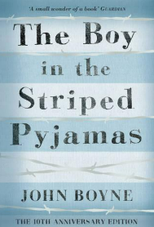  The Boy in the Striped Pyjamas by John Boyne
Curriculum Stimuli | Big Project Question | Opinions about slavery differed during the European slave trade; why was this and is it still the case? |  |  | What measures can we take to preserve the delicate balance of the polar regions in the face of climate change? |  | Who or what contributed most to the war effort in Britain during WW2?
Curriculum Stimuli | Curriculum Immersion Day | Performance celebrating African culture |  |  | Polar Expedition |  | Evacuation Day
Curriculum Stimuli | Significant Individual | Claudia Jones |  |  | Ernest Shackleton |  | Adolf Hitler
Curriculum Drivers | Opportunity | Visiting Liverpool Museum |  |  | ETE’s Polar Fun Days schools (invite a Polar Explorer into the classroom to tell stories of their expeditions and the environments they have travelled through) |  | Eden Camp
Curriculum Drivers | Community | Speak to a local poet during national poetry day and perform poems at the local care home |  |  | Litter picking in Stanley – thinking about things that the school and the local community can do to help the environment  British Values Week – Community Project |  | Write or speak to war veterans in the local community
Curriculum Drivers | Diversity | Finding out, empathising and becoming more aware of the history of slavery and how it has affected the black community |  |  | Learn about indigenous people |  | Consider the oppression different groups faced under the rule of Hitler
Curriculum Subjects | PSHE | Me and My Relationships |  | Valuing Difference | Keeping Myself Save | Rights and Responsibilities | Being my Best | Growing and Changing
Curriculum Subjects | Religious Education | What matters most to Christians and Humanists?  Living | What can be done to reduce racism? Can religion help?  Living |  | Is it better to express your beliefs in arts and architecture or in charity and generosity?  Expressing | Green religion? Caring for the Earth.  Living | What do religions and world views say when life gets hard?  Believing
Curriculum Subjects | Science | Animals Including Humans |  | Light | Electricity | Living Things and Their Habitats | Evolution and Inheritance | Enrichment/transition project
Curriculum Subjects | Design & Technology | Food For Life |  |  | Engineer |  | Make Do and Mend
Curriculum Subjects | French | Phonics 3&4  Do you have a pet? |  |  | At the Tea Room |  | Planets
Curriculum Subjects | Computing | Communication |  | Web Page Creation | Variables in Games | Introduction to Spreadsheets | 3D Modelling | Sensing
Curriculum Subjects | Geography | Africa – countries, land use, natural resources, location, settlements, population, climate and physical features |  |  | Characteristics and features of polar regions |  | Interconnections between two or more areas of the world
Curriculum Subjects | History | The development of the transatlantic slave trade and Britain's role in the slave trade |  |  | Polar exploration |  | Causes, events and consequences of the First and Second World Wars
Curriculum Subjects | Music | Music and Technology |  | Developing Ensemble Skills | Creative Composition | Musical Styles Connect Us | Improvising with Confidence | Farewell Tour
Curriculum Subjects | Art & design | Trailblazers, Barrier breakers  Exploring the work of barrier breaking black artists. |  |  | Inuit  Art, craft and traditions from the Inuit culture. |  | Bees, Beetles and Butterflies  Artwork linked to nature and the natural world.
Curriculum Subjects | Physical Education | Dance |  |  | Hockey | Tag Rugby | Dodgeball | Golf

