 |  | Autumn |  | Spring |  | Summer
Curriculum Stimuli | Project Title | Through The Ages  (Companion Project – Prehistoric Pots) |  | Misty Mountain, Winding River  (Companion Project – Vista) |  | Emperors and Empires  (Companion Project – Mosaic masters)
Curriculum Stimuli | Book | Stig of the Dump by Clive King  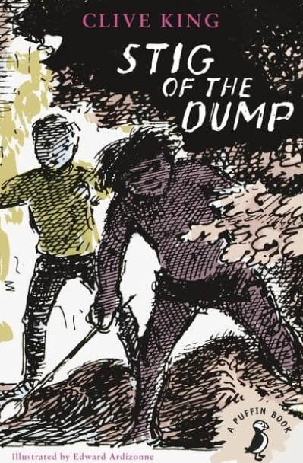 |  | 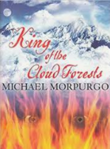  King of the Cloud Forest by Michael Morpurgo |  | 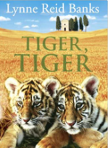  Tiger, Tiger by Lynne Read Banks
Curriculum Stimuli | Big Project Question | How did human invention and ingenuity change how people lived during the Prehistoric era? |  | What role do mountains and rivers play in our ever-changing environment? |  | How did the rise and fall of Ancient Rome impact everyday life in Britain?
Curriculum Stimuli | Immersion Day | Through the Ages immersion day |  | Misty Mountain, Winding River immersion day |  | Emperors and Empires immersion day
Curriculum Stimuli | Significant Individual | Amesbury Archer |  | Alan Hinkes OBE (famous mountaineer) |  | Boudicca
Curriculum Drivers | Opportunity | Through the Ages workshop |  | Yorkshire Water Treatment Works |  | Royal Armouries visit
Curriculum Drivers | Community
Curriculum Drivers | Diversity
Curriculum Subjects | PSHE | Me and My Relationships | Valuing Differences | Keeping Safe | Rights and Responsibilities | Being My Best | Growing and Changing
Curriculum Subjects | Religious Education | How do family life and festivals show what matters to Jewish  people? | How do people from religious and non-religious communities  celebrate key festivals? | Why is the Bible important for Christians today? | What can we learn from religions about deciding what is right and wrong? | What does it mean to be a Christian in Britain today? | Why do some people think that life is a journey? What significant experiences mark this?
Curriculum Subjects | Science | Animals Including Humans | Living Things and Their Habitats | States of Matter |  | Plants | Light
Curriculum Subjects | Design & Technology | Cook Well, Eat Well |  | Functional & Fancy Fabrics |  | Greenhouse
Curriculum Subjects | French | Phonics 1&2  Instruments |  | Vegetables |  | Presenting Myself
Curriculum Subjects | Computing | The Internet | Repetition in Shapes | Audio Editing | Repetition in Games | Data Logging | Photo Editing
Curriculum Subjects | Geography | Stone Age Monuments |  | Characteristics and features of rivers and mountain ranges around the world |  | European countries and major cities
Curriculum Subjects | History | Stone Age to the Iron Age |  | Significant people: Alfred Barnhard Nobel/ or Bernard Palissy |  | Ancient Rome and the Roman Empire
Curriculum Subjects | Music
Curriculum Subjects | Art & design | Bell Beaker Pottery |  | Create a landscape with an unusual perspective and viewpoint using a viewfinder. |  | Roman Mosaics
Curriculum Subjects | Physical Education | Dance (Year 4) | Dance (Year 4) | Handball | Handball | Golf | Tennis

