



Dear Parents and Carers,

We are excited to invite you to our ‘Stay and play’ session for Reception and Nursery on Monday 6th July at 9 am.
We will have lots of fun summer time and mini beast activities for you to engage in with your child. It will be an opportunity for you to see how much your child has progressed at school and explore the classroom environment together once again. We are looking forward to spending the morning with you all!

Kind regards,

Early Years Team
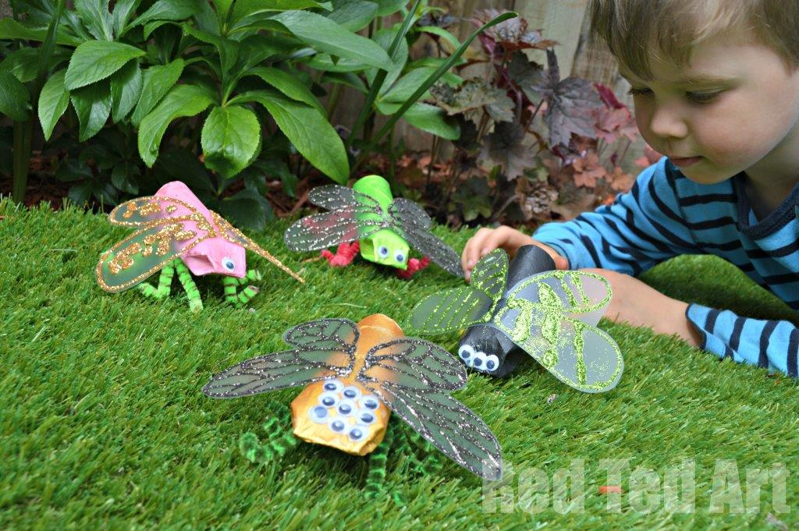
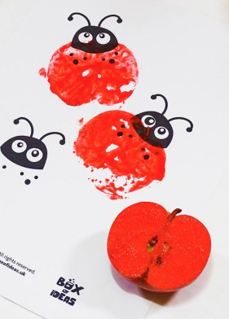





Our School Values are: Perseverance, Courage, Forgiveness, Friendship, Honesty and Acceptance








