Stanley St Peter’s CE Primary School

Child Friendly Anti-Bullying Policy

Our statement on bullying
Our school is a place where everyone has the right to be themselves.
It’s a place where everyone can feel safe, be happy and learn.
Everyone at our school is included and acts with respect and kindness towards each other.
Our school values are Friendship, Forgiveness, Courage, Perseverance, Honesty and Acceptance and we use these to help us be good citizens.
Our school takes bullying very seriously.

What is bullying?
Bullying is when a person is hurtful or unkind to someone else on purpose and usually more than once.
Bullying can be done by one person or a group of people.
An easy way to remember what bullying is…
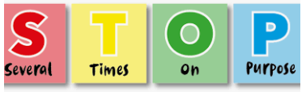
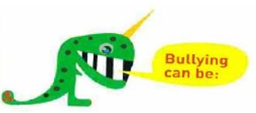
Hitting or saying you are going to hit someone.
Touching someone when they don’t want you to.
Calling someone names, teasing them, using rude language or saying nasty things about someone to them or others.
Stealing or damaging other people’s things.
Ignoring someone on purpose or leaving them out.
Sending hurtful or unkind text messages, emails or online messages to someone or about someone.

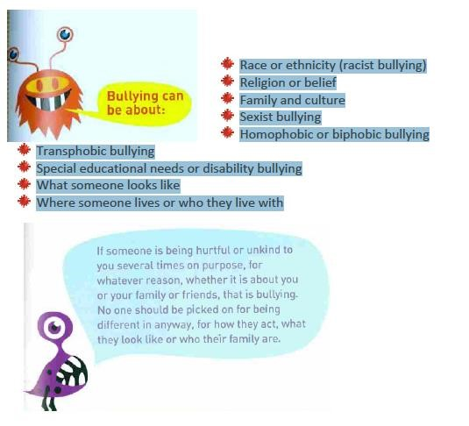

Why does bullying happen?
Although bullying doesn’t happen very much at this school it might happen. Pupils who bully can be older, younger, bigger or smaller than you. Pupils who bully pick on people who may be different in some way and try to make them feel worse about themselves. If you are being bullied remember that it is never your fault.

Where does bullying happen?
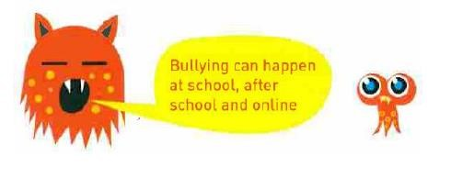

What should I do if I think someone is being bullied?
In our school we all take responsibility in keeping each other safe. It is never OK to see someone being bullied and do nothing (being a bystander). You can tell people to stop (become a defender) or you can tell an adult about what has happened. If you think someone is being bullied then talk to the person, ask if they’re OK and ask if you can help them talk to a teacher or an adult they trust.
What should I do if I’m being bullied?
If you are being bullied it is important to tell someone you trust. Tell an adult or friend, either at school or at home.
If you have already told an adult about bullying you can still tell them again.
You can:
- Tell a teacher – your class teacher or any other teacher
- Tell a friend you trust
- Tell any other adult staff in school – such as Teaching Assistants, midday supervisors or the school office
- Tell an adult at home
- You can also write a note about the bullying in your class and put it in the worry monster.
- You can also call ChildLine at any time for free on 0800 1111. They will not tell anyone about what you have said.

If you tell a teacher or adult at school, they will be able to help you. They will tell the headteacher and your parent or carer so that they can help you. Telling an adult will never make bullying worse. They will talk to you and the people bullying you to find ways to stop the bullying and keep you safe.

Mrs Hick is our named Anti-Bullying Lead and Mrs Chan is our named Anti-Bullying Governor but you can talk to anyone in school and they will help!

